






Facilitate outgoing phone calls
D1.HFO.CL2.10
Trainer Guide

Facilitate outgoing phone calls

D1.HFO.CL2.10

Trainer Guide




Project Base
William Angliss Institute of TAFE
555 La Trobe Street
Melbourne 3000 Victoria
Telephone: | (03) 9606 2111
Facsimile: | (03) 9670 1330
Acknowledgements
Project Director: | Wayne Crosbie
Chief Writer: | Alan Hickman
Subject Writers: | Evelyn Collins and Linda Wilson
Project Manager/Editor: | Alan Maguire
DTP/Production: | Daniel Chee, Mai Vu, Jirayu Thangcharoensamut, Kaly Quach

The Association of Southeast Asian Nations (ASEAN) was established on 8 August 1967. The Member States of the Association are Brunei Darussalam, Cambodia, Indonesia, Lao PDR, Malaysia, Myanmar, Philippines, Singapore, Thailand and Viet Nam.
The ASEAN Secretariat is based in Jakarta, Indonesia.
General Information on ASEAN appears online at the ASEAN Website: www.asean.org.
All text is produced by William Angliss Institute of TAFE for the ASEAN Project on “Toolbox Development for Front Office, Food and Beverage Services and Food Production Divisions”.
This publication is supported by the Australian Government’s aid program through the ASEAN-Australia Development Cooperation Program Phase II (AADCP II).
Copyright: Association of Southeast Asian Nations (ASEAN) 2013.
All rights reserved.
Disclaimer
Every effort has been made to ensure that this publication is free from errors or omissions. However, you should conduct your own enquiries and seek professional advice before relying on any fact, statement or matter contained in this book. The ASEAN Secretariat and William Angliss Institute of TAFE are not responsible for any injury, loss or damage as a result of material included or omitted from this course. Information in this module is current at the time of publication. Time of publication is indicated in the date stamp at the bottom of each page.
Some images appearing in this resource have been purchased from stock photography suppliers Shutterstock and iStockphoto and other third party copyright owners and as such are non-transferable and non-exclusive. Clip arts, font images and illustrations used are from the Microsoft Office Clip Art and Media Library. Some images have been provided by and are the property of William Angliss Institute.
Additional images have been sourced from Flickr and SXC and are used under Creative Commons licence: http://creativecommons.org/licenses/by/2.0/deed.en
File name: TG_Facilitate_outgoing_phone_calls_refined.docx





Table of contents
Competency Based Training (CBT) and assessment - An introduction for trainers 1
Competency standard 11
Notes and PowerPoint slides 19
Recommended training equipment 55
Instructions for Trainers for using PowerPoint – Presenter View 57
Appendix – ASEAN acronyms 59

Competency Based Training (CBT) and assessment - An introduction for trainers

Competency
Competency refers to the ability to perform particular tasks and duties to the standard of performance expected in the workplace.
Competency requires the application of specified knowledge, skills and attitudes relevant to effective participation, consistently over time and in the workplace environment.
The essential skills and knowledge are either identified separately or combined.
Knowledge identifies what a person needs to know to perform the work in an informed and effective manner.
Skills describe the application of knowledge to situations where understanding is converted into a workplace outcome.
Attitude describes the founding reasons behind the need for certain knowledge or why skills are performed in a specified manner.
Competency covers all aspects of workplace performance and involves:
- Performing individual tasks
- Managing a range of different tasks
- Responding to contingencies or breakdowns
- Dealing with the responsibilities of the workplace
- Working with others.

Unit of Competency
Like with any training qualification or program, a range of subject topics are identified that focus on the ability in a certain work area, responsibility or function.
Each manual focuses on a specific unit of competency that applies in the hospitality workplace.
In this manual a unit of competency is identified as a ‘unit’.
Each unit of competency identifies a discrete workplace requirement and includes:
- Knowledge and skills that underpin competency
- Language, literacy and numeracy
- Occupational safety and health requirements.
Each unit of competency must be adhered to in training and assessment to ensure consistency of outcomes.

Element of Competency
An element of competency describes the essential outcomes within a unit of competency.
The elements of competency are the basic building blocks of the unit of competency. They describe in terms of outcomes the significant functions and tasks that make up the competency.
In this manual elements of competency are identified as an ‘element’.

Performance criteria
Performance criteria indicate the standard of performance that is required to demonstrate achievement within an element of competency. The standards reflect identified industry skill needs.
Performance criteria will be made up of certain specified skills, knowledge and attitudes.

Learning
For the purpose of this manual learning incorporates two key activities:
- Training
- Assessment.
Both of these activities will be discussed in detail in this introduction.
Today training and assessment can be delivered in a variety of ways. It may be provided to participants:
- On-the-job – in the workplace
- Off-the-job – at an educational institution or dedicated training environment
- As a combination of these two options.
No longer is it necessary for learners to be absent from the workplace for long periods of time in order to obtain recognised and accredited qualifications.

Learning Approaches
This manual will identify two avenues to facilitate learning:
Competency Based Training (CBT)
This is the strategy of developing a participant’s competency.
Educational institutions utilise a range of training strategies to ensure that participants are able to gain the knowledge and skills required for successful:
- Completion of the training program or qualification
- Implementation in the workplace.
The strategies selected should be chosen based on suitability and the learning styles of participants.

Competency Based Assessment (CBA)
This is the strategy of assessing competency of a participant.
Educational institutions utilise a range of assessment strategies to ensure that participants are assessed in a manner that demonstrates validity, fairness, reliability, flexibility and fairness of assessment processes.

Flexibility in Learning
It is important to note that flexibility in training and assessment strategies is required to meet the needs of participants who may have learning difficulties. The strategies used will vary, taking into account the needs of individual participants with learning difficulties. However they will be applied in a manner which does not discriminate against the participant or the participant body as a whole.
Catering for Participant Diversity
Participants have diverse backgrounds, needs and interests. When planning training and assessment activities to cater for individual differences, trainers and assessors should:
- Consider individuals’ experiences, learning styles and interests
- Develop questions and activities that are aimed at different levels of ability
- Modify the expectations for some participants
- Provide opportunities for a variety of forms of participation, such as individual, pair and small group activities
- Assess participants based on individual progress and outcomes.
The diversity among participants also provides a good reason for building up a learning community in which participants support each other’s learning.
Participant Centred Learning
This involves taking into account structuring training and assessment that:
- Builds on strengths – Training environments need to demonstrate the many positive features of local participants (such as the attribution of academic success to effort, and the social nature of achievement motivation) and of their trainers (such as a strong emphasis on subject disciplines and moral responsibility). These strengths and uniqueness of local participants and trainers should be acknowledged and treasured
- Acknowledges prior knowledge and experience – The learning activities should be planned with participants’ prior knowledge and experience in mind
- Understands learning objectives – Each learning activity should have clear learning objectives and participants should be informed of them at the outset. Trainers should also be clear about the purpose of assignments and explain their significance to participants
- Teaches for understanding – The pedagogies chosen should aim at enabling participants to act and think flexibly with what they know
- Teaches for independent learning – Generic skills and reflection should be nurtured through learning activities in appropriate contexts of the curriculum. Participants should be encouraged to take responsibility for their own learning
- Enhances motivation – Learning is most effective when participants are motivated. Various strategies should be used to arouse the interest of participants
- Makes effective use of resources – A variety of teaching resources can be employed as tools for learning
- Maximises engagement – In conducting learning activities, it is important for the minds of participants to be actively engaged
- Aligns assessment with learning and teaching – Feedback and assessment should be an integral part of learning and teaching
- Caters for learner diversity – Trainers should be aware that participants have different characteristics and strengths and try to nurture these rather than impose a standard set of expectations.
Active Learning
The goal of nurturing independent learning in participants does not imply that they always have to work in isolation or solely in a classroom. On the contrary, the construction of knowledge in tourism and hospitality studies can often best be carried out in collaboration with others in the field. Sharing experiences, insights and views on issues of common concern, and working together to collect information through conducting investigative studies in the field (active learning) can contribute a lot to their eventual success.
Active learning has an important part to play in fostering a sense of community in the class. First, to operate successfully, a learning community requires an ethos of acceptance and a sense of trust among participants, and between them and their trainers. Trainers can help to foster acceptance and trust through encouragement and personal example, and by allowing participants to take risks as they explore and articulate their views, however immature these may appear to be. Participants also come to realise that their classmates (and their trainers) are partners in learning and solving.
Trainers can also encourage cooperative learning by designing appropriate group learning tasks, which include, for example, collecting background information, conducting small-scale surveys, or producing media presentations on certain issues and themes. Participants need to be reminded that, while they should work towards successful completion of the field tasks, developing positive peer relationships in the process is an important objective of all group work.

Competency Based Training (CBT)
Principle of Competency Based Training
Competency based training is aimed at developing the knowledge, skills and attitudes of participants, through a variety of training tools.
Training Strategies
The aims of this curriculum are to enable participants to:
- Undertake a variety of subject courses that are relevant to industry in the current environment
- Learn current industry skills, information and trends relevant to industry
- Learn through a range of practical and theoretical approaches
- Be able to identify, explore and solve issues in a productive manner
- Be able to become confident, equipped and flexible managers of the future
- Be ‘job ready’ and a valuable employee in the industry upon graduation of any qualification level.
To ensure participants are able to gain the knowledge and skills required to meet competency in each unit of competency in the qualification, a range of training delivery modes are used.
Types of Training
In choosing learning and teaching strategies, trainers should take into account the practical, complex and multi-disciplinary nature of the subject area, as well as their participant’s prior knowledge, learning styles and abilities.
Training outcomes can be attained by utilising one or more delivery methods:
Lecture/Tutorial
This is a common method of training involving transfer of information from the trainer to the participants. It is an effective approach to introduce new concepts or information to the learners and also to build upon the existing knowledge. The listener is expected to reflect on the subject and seek clarifications on the doubts.
Demonstration
Demonstration is a very effective training method that involves a trainer showing a participant how to perform a task or activity. Through a visual demonstration, trainers may also explain reasoning behind certain actions or provide supplementary information to help facilitate understanding.
Group Discussions
Brainstorming in which all the members in a group express their ideas, views and opinions on a given topic, is a free flow and exchange of knowledge among the participants and the trainer. The discussion is carried out by the group on the basis of their own experience, perceptions and values. This will facilitate acquiring new knowledge. When everybody is expected to participate in the group discussion, even the introverted persons will also get stimulated and try to articulate their feelings.
The ideas that emerge in the discussions should be noted down and presentations are to be made by the groups. Sometimes consensus needs to be arrived at on a given topic. Group discussions are to be held under the moderation of a leader guided by the trainer. Group discussion technique triggers thinking process, encourages interactions and enhances communication skills.
Role Play
This is a common and very effective method of bringing into the classroom real life situations, which may not otherwise be possible. Participants are made to enact a particular role so as to give a real feel of the roles they may be called upon to play. This enables participants to understand the behaviour of others as well as their own emotions and feelings. The instructor must brief the role players on what is expected of them. The role player may either be given a ready-made script, which they can memorise and enact, or they may be required to develop their own scripts around a given situation. This technique is extremely useful in understanding creative selling techniques and human relations. It can be entertaining and energising and it helps the reserved and less literate to express their feelings.

Simulation Games
When trainees need to become aware of something that they have not been conscious of, simulations can be a useful mechanism. Simulation games are a method based on "here and now" experience shared by all the participants. The games focus on the participation of the trainees and their willingness to share their ideas with others. A "near real life" situation is created providing an opportunity to which they apply themselves by adopting certain behaviour. They then experience the impact of their behaviour on the situation. It is carried out to generate responses and reactions based on the real feelings of the participants, which are subsequently analysed by the trainer.
While use of simulation games can result in very effective learning, it needs considerable trainer competence to analyse the situations.
Individual /Group Exercises
Exercises are often introduced to find out how much the participant has assimilated. This method involves imparting instructions to participants on a particular subject through use of written exercises. In the group exercises, the entire class is divided into small groups, and members are asked to collaborate to arrive at a consensus or solution to a problem.
Case Study
This is a training method that enables the trainer and the participant to experience a real life situation. It may be on account of events in the past or situations in the present, in which there may be one or more problems to be solved and decisions to be taken. The basic objective of a case study is to help participants diagnose, analyse and/or solve a particular problem and to make them internalise the critical inputs delivered in the training. Questions are generally given at the end of the case study to direct the participants and to stimulate their thinking towards possible solutions. Studies may be presented in written or verbal form.
Field Visit
This involves a carefully planned visit or tour to a place of learning or interest. The idea is to give first-hand knowledge by personal observation of field situations, and to relate theory with practice. The emphasis is on observing, exploring, asking questions and understanding. The trainer should remember to brief the participants about what they should observe and about the customs and norms that need to be respected.
Group Presentation
The participants are asked to work in groups and produce the results and findings of their group work to the members of another sub-group. By this method participants get a good picture of each other's views and perceptions on the topic and they are able to compare them with their own point of view. The pooling and sharing of findings enriches the discussion and learning process.
Practice Sessions
This method is of paramount importance for skills training. Participants are provided with an opportunity to practice in a controlled situation what they have learnt. It could be real life or through a make-believe situation.

Games
This is a group process and includes those methods that involve usually fun-based activity, aimed at conveying feelings and experiences, which are everyday in nature, and applying them within the game being played. A game has set rules and regulations, and may or may not include a competitive element. After the game is played, it is essential that the participants be debriefed and their lessons and experiences consolidated by the trainer.
Research
Trainers may require learners to undertake research activities, including online research, to gather information or further understanding about a specific subject area.

Competency Based Assessment (CBA)
Principle of Competency Based Assessment
Competency based assessment is aimed at compiling a list of evidence that shows that a person is competent in a particular unit of competency.
Competencies are gained through a multitude of ways including:
- Training and development programs
- Formal education
- Life experience
- Apprenticeships
- On-the-job experience
- Self-help programs.
All of these together contribute to job competence in a person. Ultimately, assessors and participants work together, through the ‘collection of evidence’ in determining overall competence.
This evidence can be collected:
- Using different formats
- Using different people
- Collected over a period of time.
The assessor, who is ideally someone with considerable experience in the area being assessed, reviews the evidence and verifies the person as being competent or not.
Flexibility in Assessment
Whilst allocated assessment tools have been identified for this subject, all attempts are made to determine competency and suitable alternate assessment tools may be used, according to the requirements of the participant.
The assessment needs to be equitable for all participants, taking into account their cultural and linguistic needs.
Competency must be proven regardless of:
- Language
- Delivery Method
- Assessment Method.
Assessment Objectives
The assessment tools used for subjects are designed to determine competency against the ‘elements of competency’ and their associated ‘performance criteria’.
The assessment tools are used to identify sufficient:
- Knowledge, including underpinning knowledge
- Skills
- Attitudes
Assessment tools are activities that trainees are required to undertake to prove participant competency in this subject.
All assessments must be completed satisfactorily for participants to obtain competence in this subject. There are no exceptions to this requirement, however, it is possible that in some cases several assessment items may be combined and assessed together.
Types of Assessment
Allocated Assessment Tools
There are a number of assessment tools that are used to determine competency in this subject:
- Work projects
- Written questions
- Oral questions
- Third Party Report
- Observation Checklist.
Instructions on how assessors should conduct these assessment methods are explained in the Assessment Manuals.
Alternative Assessment Tools
Whilst this subject has identified assessment tools, as indicated above, this does not restrict the assessor from using different assessment methods to measure the competency of a participant.
Evidence is simply proof that the assessor gathers to show participants can actually do what they are required to do.
Whilst there is a distinct requirement for participants to demonstrate competency, there are many and diverse sources of evidence available to the assessor.
Ongoing performance at work, as verified by a supervisor or physical evidence, can count towards assessment. Additionally, the assessor can talk to customers or work colleagues to gather evidence about performance.
A range of assessment methods to assess competency include:
- Practical demonstrations
- Practical demonstrations in simulated work conditions
- Problem solving
- Portfolios of evidence
- Critical incident reports
- Journals
- Oral presentations
- Interviews
- Videos
- Visuals: slides, audio tapes
- Case studies
- Log books
- Projects
- Role plays
- Group projects
- Group discussions
- Examinations.
Recognition of Prior Learning
Recognition of Prior Learning is the process that gives current industry professionals who do not have a formal qualification, the opportunity to benchmark their extensive skills and experience against the standards set out in each unit of competency/subject.
Also known as a Skills Recognition Audit (SRA), this process is a learning and assessment pathway which encompasses:
- Recognition of Current Competencies (RCC)
- Skills auditing
- Gap analysis and training
- Credit transfer.
Assessing competency
As mentioned, assessment is the process of identifying a participant’s current knowledge, skills and attitudes sets against all elements of competency within a unit of competency. Traditionally in education, grades or marks were given to participants, dependent on how many questions the participant successfully answered in an assessment tool.
Competency based assessment does not award grades, but simply identifies if the participant has the knowledge, skills and attitudes to undertake the required task to the specified standard.
Therefore, when assessing competency, an assessor has two possible results that can be awarded:
- Pass Competent (PC)
- Not Yet Competent (NYC)
- Pass Competent (PC).
If the participant is able to successfully answer or demonstrate what is required, to the expected standards of the performance criteria, they will be deemed as ‘Pass Competent’ (PC).
The assessor will award a ‘Pass Competent’ (PC) if they feel the participant has the necessary knowledge, skills and attitudes in all assessment tasks for a unit.
Not Yet Competent’ (NYC)
If the participant is unable to answer or demonstrate competency to the desired standard, they will be deemed to be ‘Not Yet Competent’ (NYC).
This does not mean the participant will need to complete all the assessment tasks again. The focus will be on the specific assessment tasks that were not performed to the expected standards.
The participant may be required to:
a) Undertake further training or instruction
b) Undertake the assessment task again until they are deemed to be ‘Pass Competent’.

Competency standard
UNIT TITLE: FACILITATE OUTGOING PHONE CALLS |  |  |  | NOMINAL HOURS: 20
UNIT NUMBER: D1.HFO.CL2.10
UNIT DESCRIPTOR: This unit deals with skills and knowledge required to assist staff or guests to place outgoing telephone calls
ELEMENTS AND PERFORMANCE CRITERIA | UNIT VARIABLE AND ASSESSMENT GUIDE
Element 1: Identify elements and facilities of the host enterprise telephone system  - Identify the types of outgoing calls that may be made and their importance to the business  - Identify the components of the telephone system  - Describe the functions and features available in the telephone system  Element 2: Demonstrate appropriate telephone communication skills  - Interpret the enterprise policies and procedures for telephone use in regard to outgoing calls  - Differentiate between face-to-face and over-the-phone communications  - Use appropriate telephone communication skills  - Use appropriate telephone techniques  - Describe acceptable telephone etiquette | Unit Variables  The Unit Variables provide advice to interpret the scope and context of this unit of competence, allowing for differences between enterprises and workplaces. It relates to the unit as a whole and facilitates holistic assessment  This unit applies to the assisting staff or guests to place outgoing telephone calls within the labour divisions of the hotel and travel industries and may include:  1. Front Office  Types of outgoing calls that may be made may be related to:  Contacting suppliers, support organisations, ordering stock and products  Contacting emergency services  Placing personal and private calls for staff, management, guests  Marketing and sales activities  Confirming reservations  Making bookings  Following-up a variety of situations  Responding to complaints  Returning calls.
Element 3: Place outgoing calls on behalf of the enterprise  - Obtain required telephone number and details of business/person to be called  - Determine purpose of call  - Place call and establish contact with required business/person  - Explain purpose of call  - Transfer connected call to caller  - Facilitate conference calls  - Implement standard re-dial procedures as required  - Log details of call in accordance with enterprise procedures  - Place emergency calls  - Enter commonly called numbers into system speed-dial facility  Element 4: Place outgoing calls on behalf of guests  - Greet guest and determine call to be made  - Obtain required telephone number and details of business/person to be called  - Place call and establish contact with required business/person  - Implement standard re-dial procedures as required | Components of the telephone system may include:  Landline telephones, including multiple lines and multiple telephone numbers  Mobile/cell phones  Paging systems  Switchboards  Handsets and headsets  Caller identification (ID) facilities, including VIP caller ID.  Functions and features available in the telephone system may be related to:  Caller ID display  Call return  Transfer and transfer recall  Placing calls ‘on hold’  Multiple chat facility  Conference call  Integration of facilities  Speed-dial  Automatic re-dial.  Enterprise policies and procedures for telephone use may include:  Privacy and confidentiality issues  Restrictions on personal use of business telephone, including bans on specific numbers  Costing of telephone calls, including personal (staff) and guests  Definitions of proper and improper use of equipment and facilities.  Standard phrases
- Log details of call in accordance with enterprise procedures  - Cost guest calls for posting to account | Authorities to use the system and nominated elements of it  Training requirements  Role of the telephone in the Emergency Management Plan.  Telephone communication skills could relate to:  Conveying a helpful and positive attitude to those wishing to place a call  Using the voice effectively and appropriately given the nature of the caller  Applying effective listening and questioning skills  Demonstrating positive speaking skills including clarity and the need to be concise  Responding professionally to all manner of requests to make outgoing calls  Choosing appropriate tone, volume and language.
Telephone techniques may include:
Clarifying caller requirements
Repeating names, dates and times
Using the phonetic alphabet when clarifying caller details
Realising the caller cannot read your facial expressions and understand other pressures that might be applicable at the time of their request for a call.
Telephone etiquette may address:
Courtesy, civility and respect
Reduction of background noise
Correct operation of system functions in order to prevent caller frustration and optimise effectiveness and efficiency in placing required call
Using outgoing caller name when known
Thanking caller
Asking caller if they would like to hold before placing them ‘on hold’
Advising caller of your intentions in respect to dealing with their outgoing call
Advising caller of the name of the person to whom their call is being directed/transferred
Apologising for delays, including never leaving a caller ‘on hold’ for longer than 30 seconds without some form of contact.
Obtain required telephone number may be related to:
Consulting internal directories
Consulting client directories
Consulting external directories, electronic and hard copy, including local, regional, national and international
Using external directory assistance
Checking relevant documentation to obtain numbers and relevant details
Checking internal databases.
Purpose of call could include:
Returning call
Making enquiry, clarifying information
Seeking information
Following-up
Selling and marketing activities
Placing order
Networking call.
Log details of call could relate to:
Recording date and time call was placed
Recording name of person/business called
Recording name of caller
Recording call duration for long-distance and international calls
Recording guest name and room number.
Emergency calls may include:
Identifying and describing nature of emergency
Giving precise location of premises and in-house emergency
Adhering to emergency management plan guidelines.
Cost guest calls may relate to:
Determining connection fee and cost per minute charges for call
Identifying duration of call
Calculating call charge using enterprise formula
Recording charges on appropriate documentation
Forwarding documentation to appropriate location for posting, including actual posting of charges where relevant electronic system permits this.
Assessment Guide
The following skills and knowledge must be assessed as part of this unit:
Knowledge of the enterprise’s policies and procedures in regard to telephone operation and implementation of the Emergency Management Plan
Principles of telephone communication
Knowledge of suitable list of local and international numbers and codes as appropriate to the enterprise and general caller requirements
Ability to use the host enterprise telephone systems and facilities
Ability to apply verbal communication, customer service, decision making, message taking and conflict resolution skills
Ability to cope under pressure.
Linkages To Other Units
Communicate on the telephone
Receive and place incoming phone calls
Provide information about in-house services
Provide international (IDD) service information
Develop and update local knowledge
Maintain hospitality industry knowledge
Receive and resolve customer complaints
Work effectively with colleagues and customers
Work in a socially diverse environment
Promote products and services to customers
Operate a telephone switchboard system, such as PABX.
Critical Aspects of Assessment
Evidence of the following is essential:
Understanding of the functions and features of the host enterprise telephone system
Demonstrated ability to implement enterprise policies on telephone use
Demonstrated ability to communicate on the telephone
Demonstrated ability to transfer calls to nominated people/extensions
Demonstrated ability to place calls ‘on hold’
Demonstrated ability to place emergency calls
Demonstrated ability to cost calls for guests accurately.
Context of Assessment
Assessment must ensure:
Actual or simulated workplace application of telephone skills.
Resource Implications
Training and assessment must include the use of a real telephone system and real callers; and access to workplace standards, procedures, policies, guidelines, tools and equipment
Assessment Methods
The following methods may be used to assess competency for this unit:
Observation of practical candidate performance
Simulated activities
Role plays
Oral and written questions
Third party reports completed by a supervisor
Project and assignment work.
Key Competencies in this Unit
Level 1 = competence to undertake tasks effectively
Level 2 = competence to manage tasks
Level 3 = competence to use concepts for evaluating
 | Key Competencies | Level | Examples
 | Collecting, organising and analysing information | 1 | Develop commonly called lists of countries, companies and individuals
 | Communicating ideas and information | 2 | Speak with callers, determine needs and respond appropriately
 | Planning and organising activities | 1 | Prepare the area for work
 | Working with others and in teams | 2 | Liaise with others to meet stated caller needs
 | Using mathematical ideas and techniques | 1 | Calculate costs for outgoing calls to be posted to guest accounts, or charged against departments
 | Solving problems | 1 | Determine time zone differences for callers; find country and other call codes
 | Using technology | 2 | Operate the telephone system and its integrated elements

Notes and PowerPoint slides
Slide

Slide No | Trainer Notes
 | Trainer welcomes the trainees and informs them that they will be learning how to facilitate outgoing phone calls.

Slide
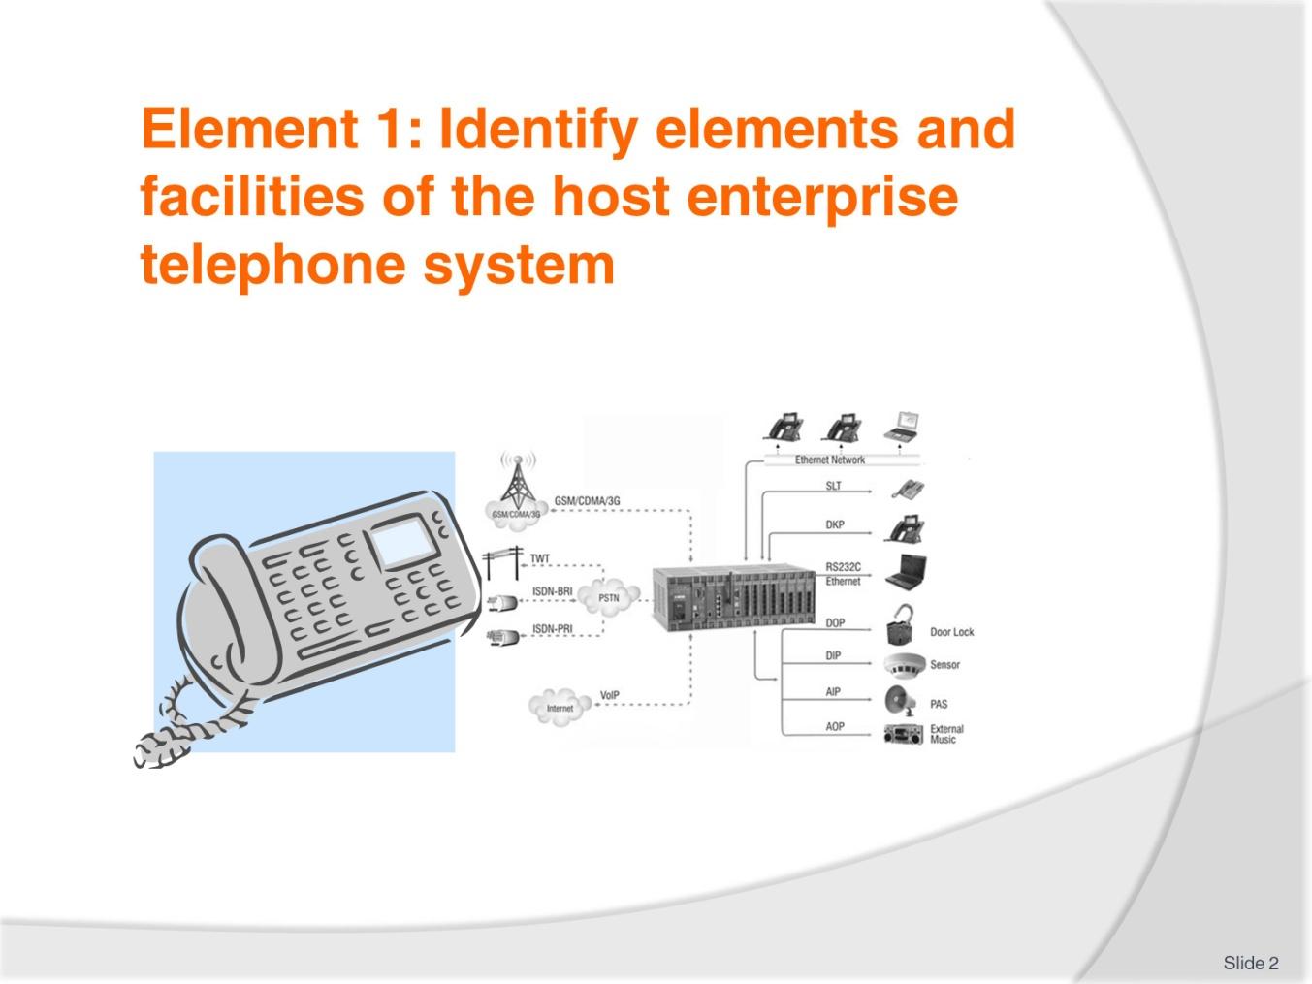
Slide No | Trainer Notes
 | Trainer advises students this element identifies the elements and facilities of the host enterprise telephone system.

Slide
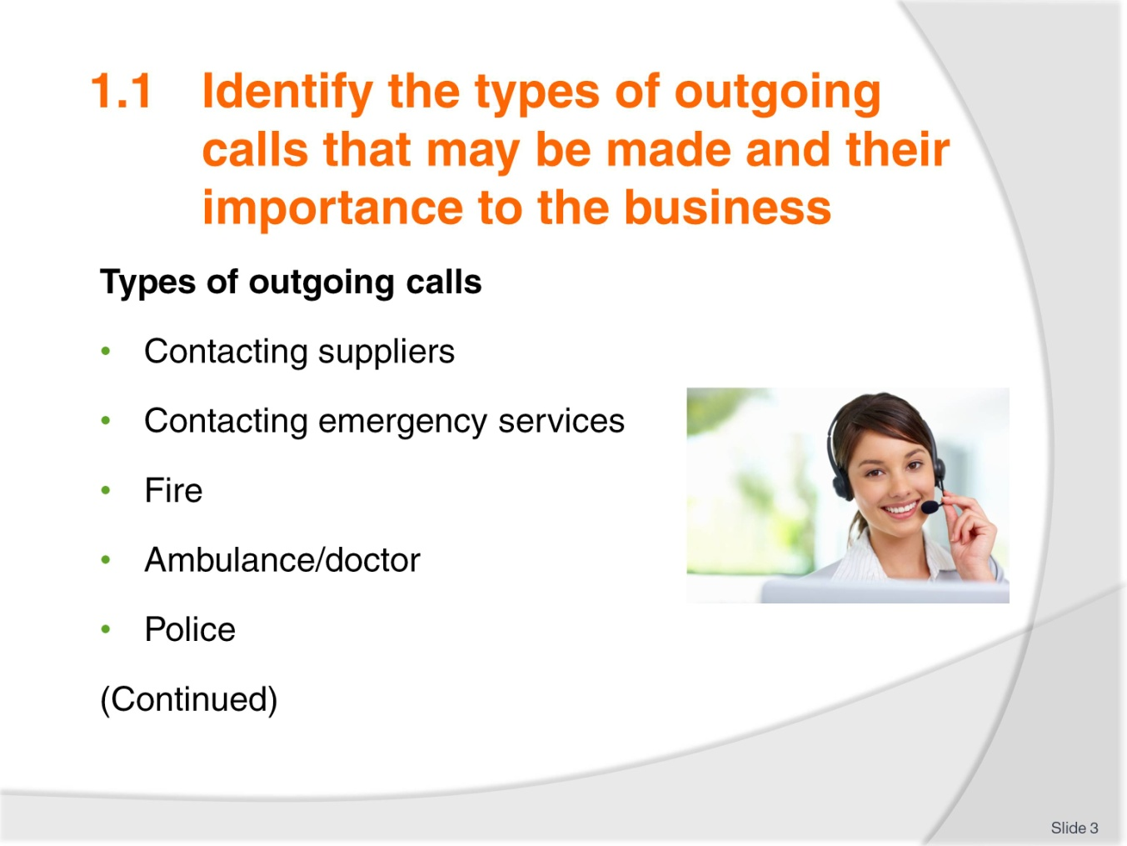
Slide No | Trainer Notes
Discuss the types of outgoing calls:
Contacting suppliers – when and who do you need to talk to?
Emergency services:
- What do you do when you have to contact the fire, ambulance and police?

Slide
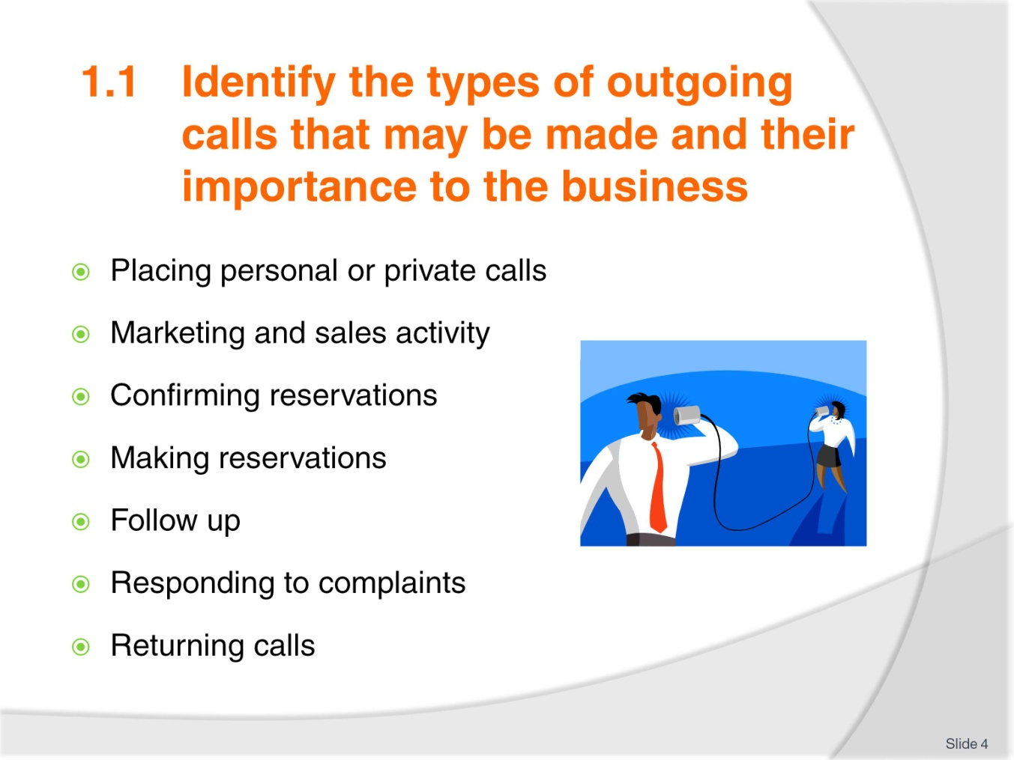
Slide No | Trainer Notes
Placing personal or private calls – often guests are unable to use the equipment and get help from the operator
Discuss the information you would need to get from the guest to make a call.

Slide
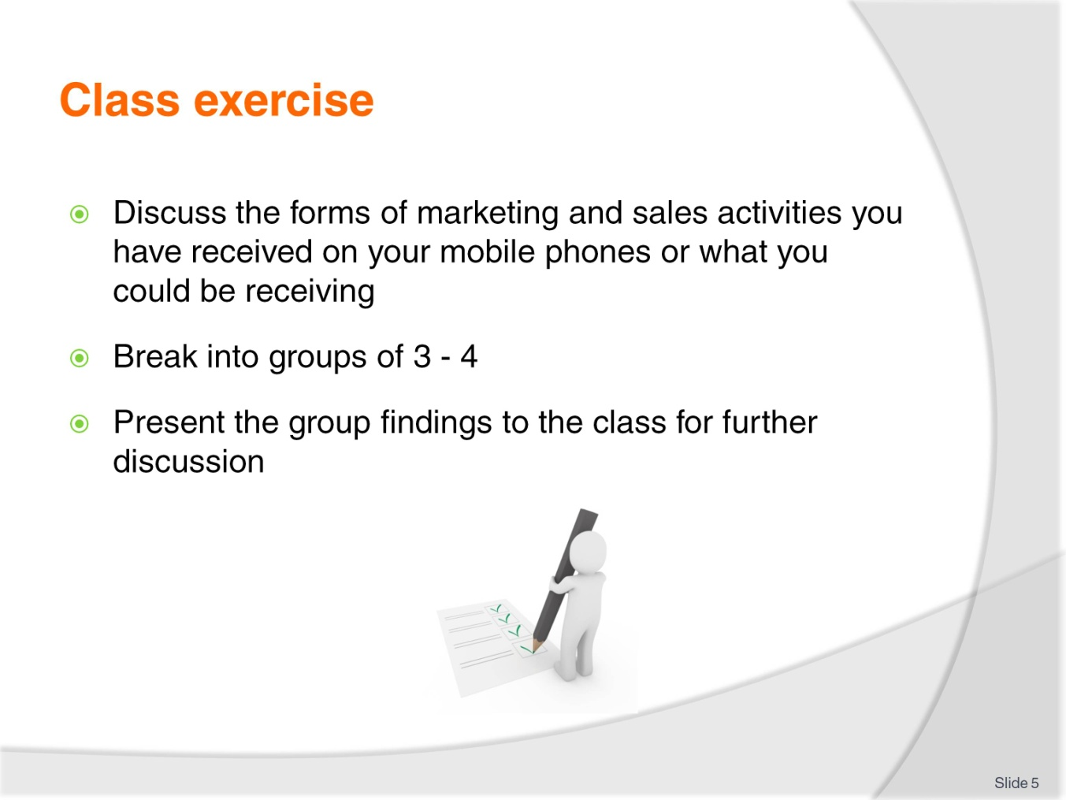
Slide No | Trainer Notes
Break the class into groups of 3 - 4 and get them to discuss the types of sales and marketing messages they get on their phones e.g. advertising from their favourite clothing store, supermarket and other retail shop specials.
You could also include confirmations you receive - the dentist, your hairdresser, your doctor, having the car serviced.

Slide
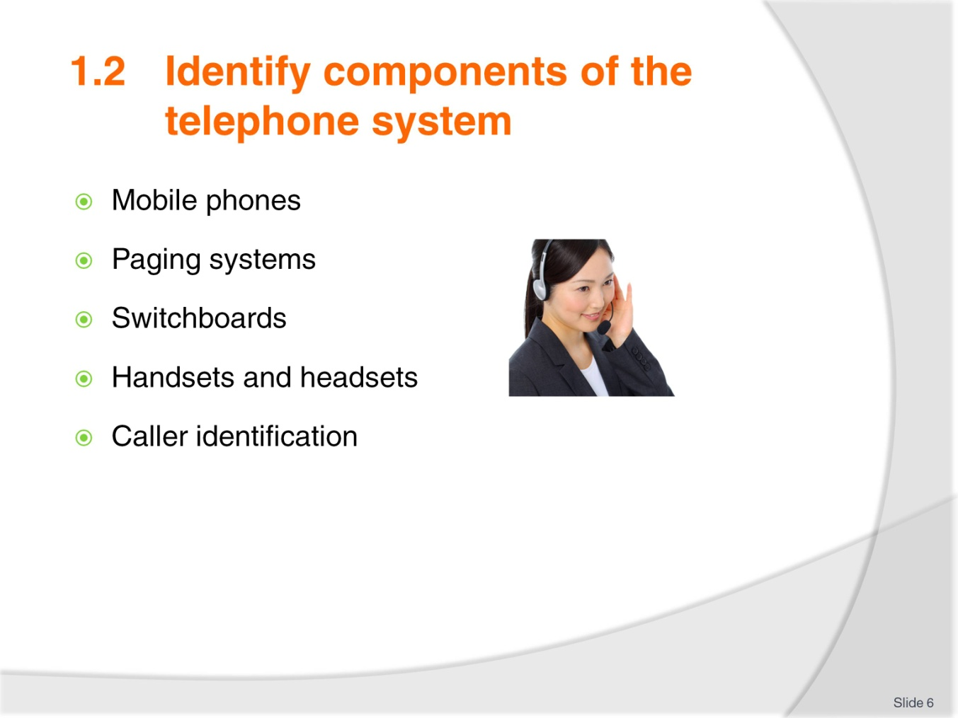
Slide No | Trainer Notes
Discuss how mobile phones are so widely used. Discuss the fact that they are so portable – especially for resorts and hotels with a lot of land.
Discuss paging systems – probably phasing out now because of cheaper mobiles.
Switchboards – how they have changed over the years from the hooks and wires to the automatic small switchboards we have today.
Handset and head sets. Ask the class if anyone has worked using one of these – McDonalds is famous for its use of headsets in the drive-thru.

Slide
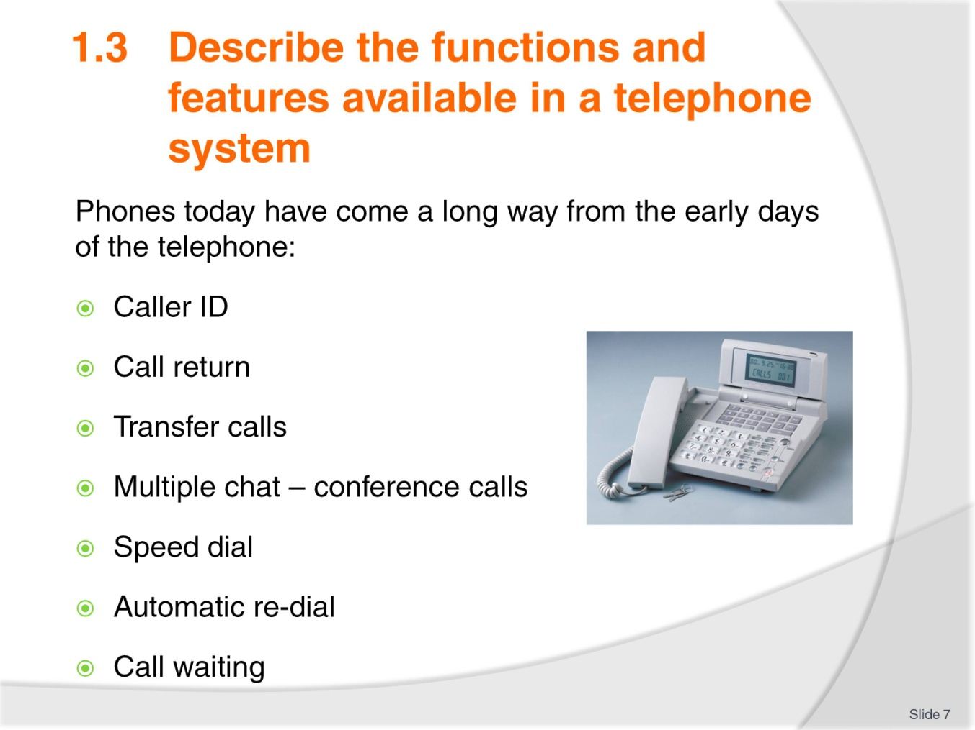
Slide No | Trainer Notes
Discuss the changes in personal phones in the life time of the trainees e.g. cameras, GPS settings, maps to get directions, the introduction of Apps, loyalty cards for coffee, paying your parking meter – all stored on your phone.
Discuss how quickly these changes have occurred. What do you think will come next?
Discuss what is available for business use; follow the points on the slide.

Slide
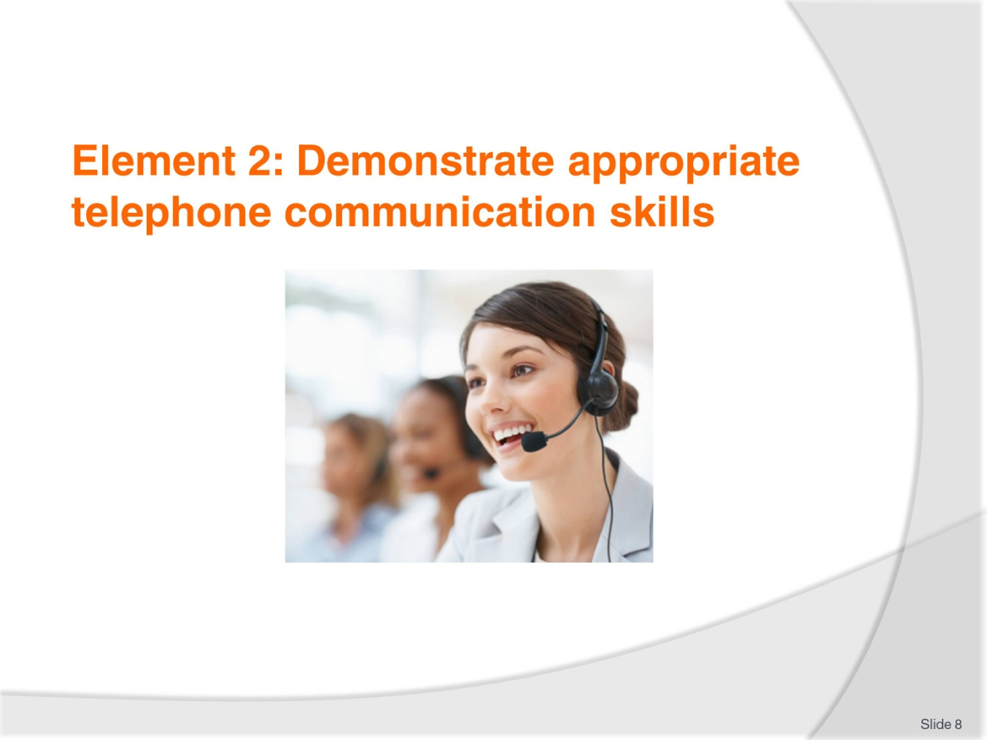
Slide No | Trainer Notes
 | Trainer advises students this element identifies appropriate telephone communication skills.

Slide
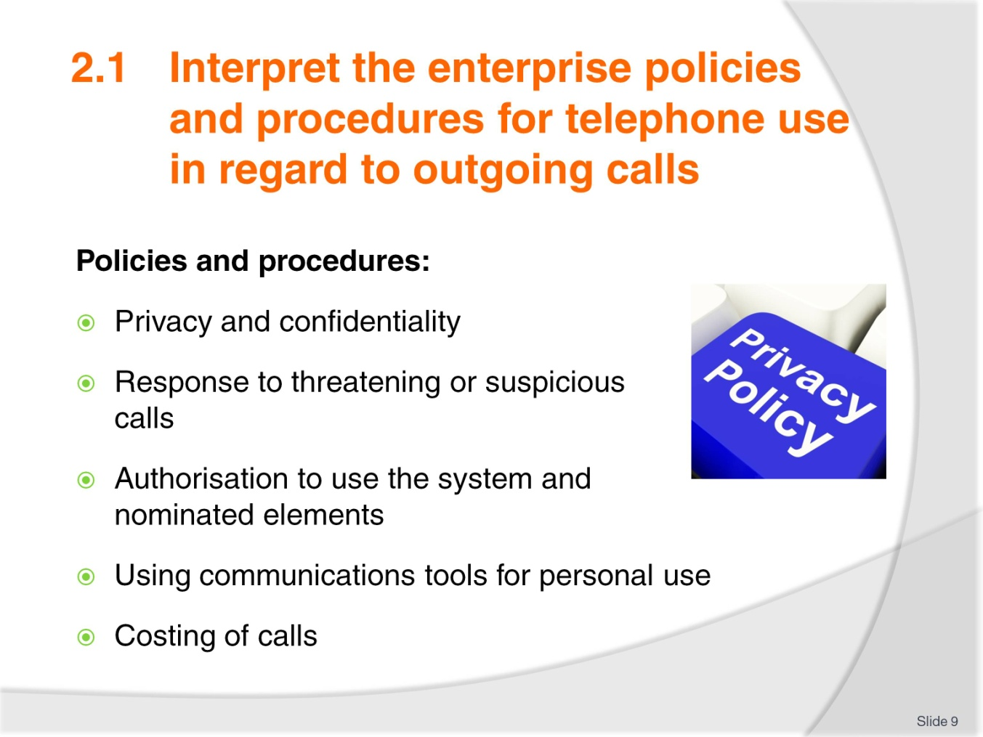
Slide No | Trainer Notes
Discuss the importance of privacy and confidentiality the staff have to the house guests. You are in possession of a lot of information about guests and must be extremely sensitive about what you do with it.
Being on reception or a telephonist you will have to act upon receiving a threatening or suspicious call. The most important thing is to remain calm.
Discuss with the class – who are you likely to call?
Personal phone calls are restricted – even when you are using your own mobile. Discuss the protocol of using your mobile phone at work.
Not all staff are authorised to use all the features on the telephone system. Pagers, for instance, might be the duty of the supervisor not the staff.
Point out to the class how guest calls are costed and any extra charges that are included; discuss how mobiles have changed this.

Slide
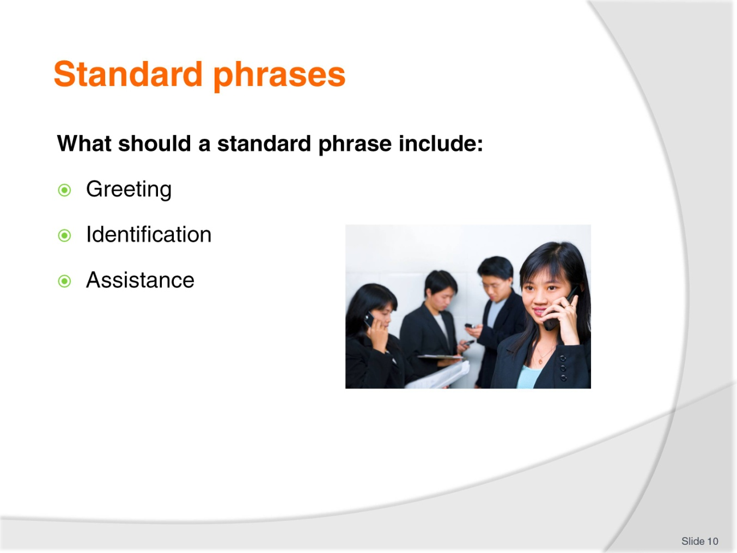
Slide No | Trainer Notes
Discuss the standard phrases to answer a call.
Suitable greeting
Identification of the establishment and the operator
Offer any assistance you can – or transfer call to someone who can help.

Slide
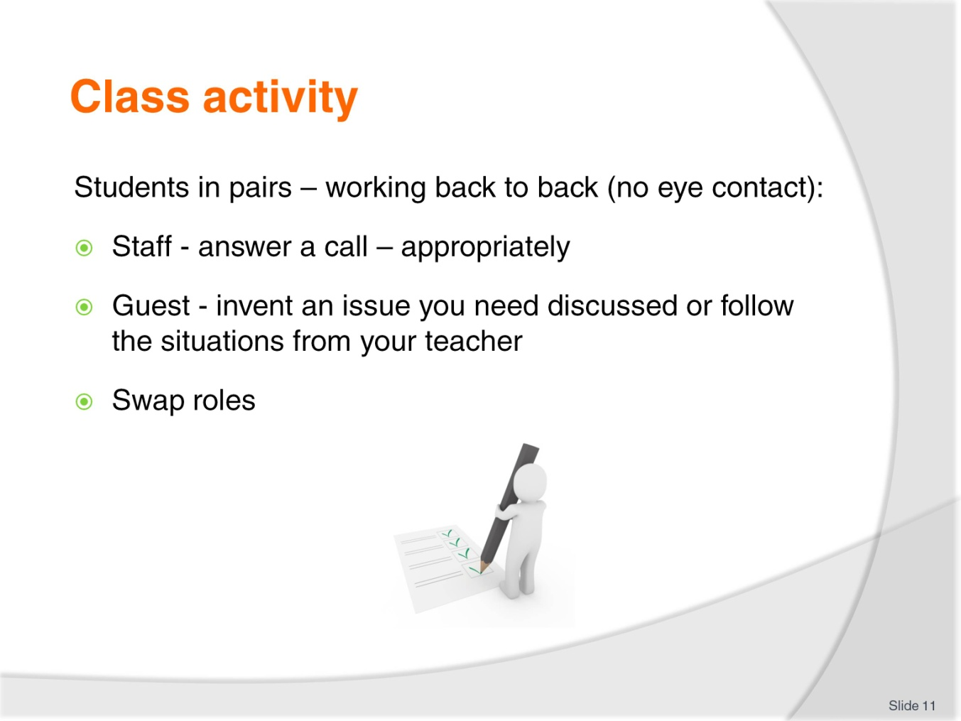
Slide No | Trainer Notes
Teacher should prepare the issues, for example:
- Guest wants to make a reservation for dinner
- Guest gives their name e.g. Mr. Blewitt, and wants speak to someone in the lounge bar
- Check that the telephone operator uses the guest’s name
- Will the call be transferred? Or the guest paged?

Slide
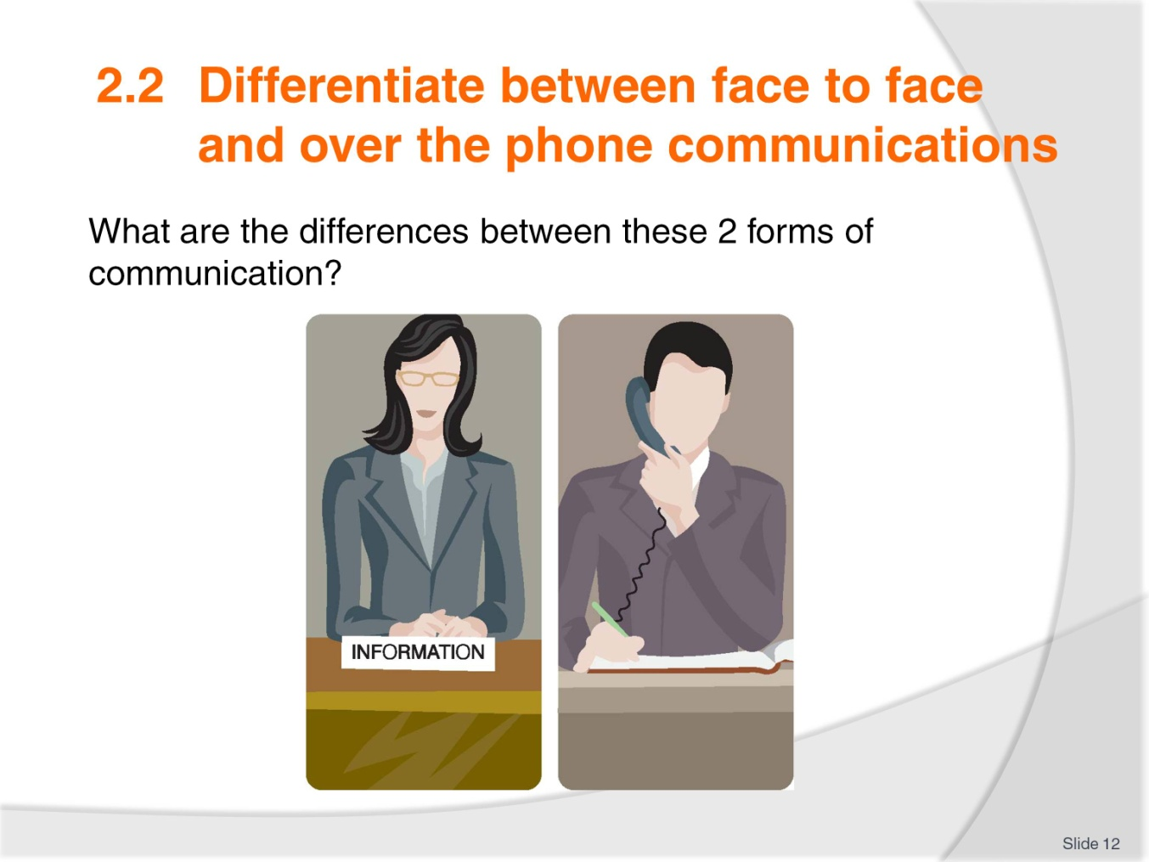
Slide No | Trainer Notes
Discuss the factors that make a difference between the 2 forms of communication.
Get the class to contribute to this topic.
Immediate response
Cannot see any expressions
No eye contact
Difficulty of accents or language barrier – no actions available
Use of questioning skills.

Slide
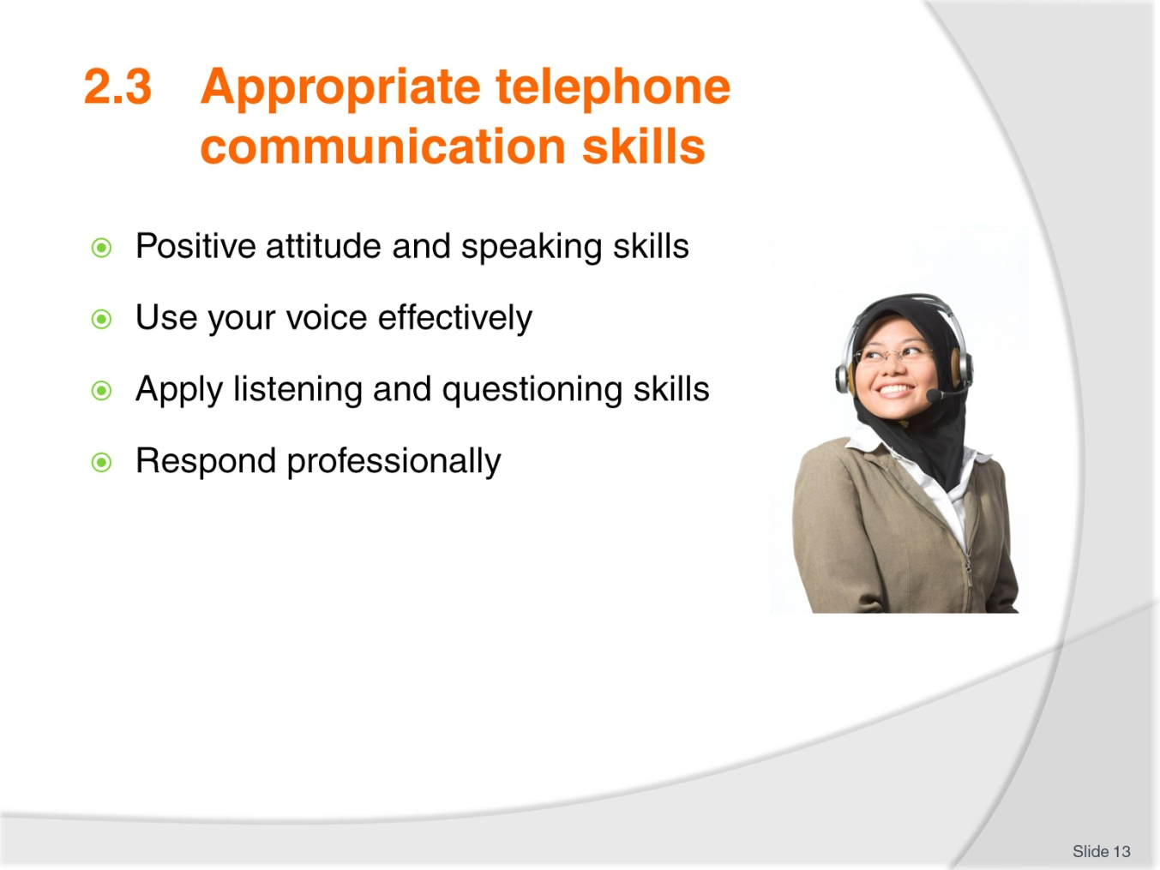
Slide No | Trainer Notes
What does it mean to have a ‘positive attitude’? Discuss with the class
Need to feel comfortable in your job – you need to feel like “you know your stuff”
Well trained on the equipment and product knowledge
Know what are the best phrases to use
Avoid jargon
Don’t use too many words
Avoid slang
Be aware of your voice – too soft too loud? Rate you speak – monotone and pitch
Your posture
Be professional – put a smile on your voice
Listening and questioning skills – discuss with class
Professional response – not YEAH – yes, discuss other words with the class that shouldn’t be used.

Slide
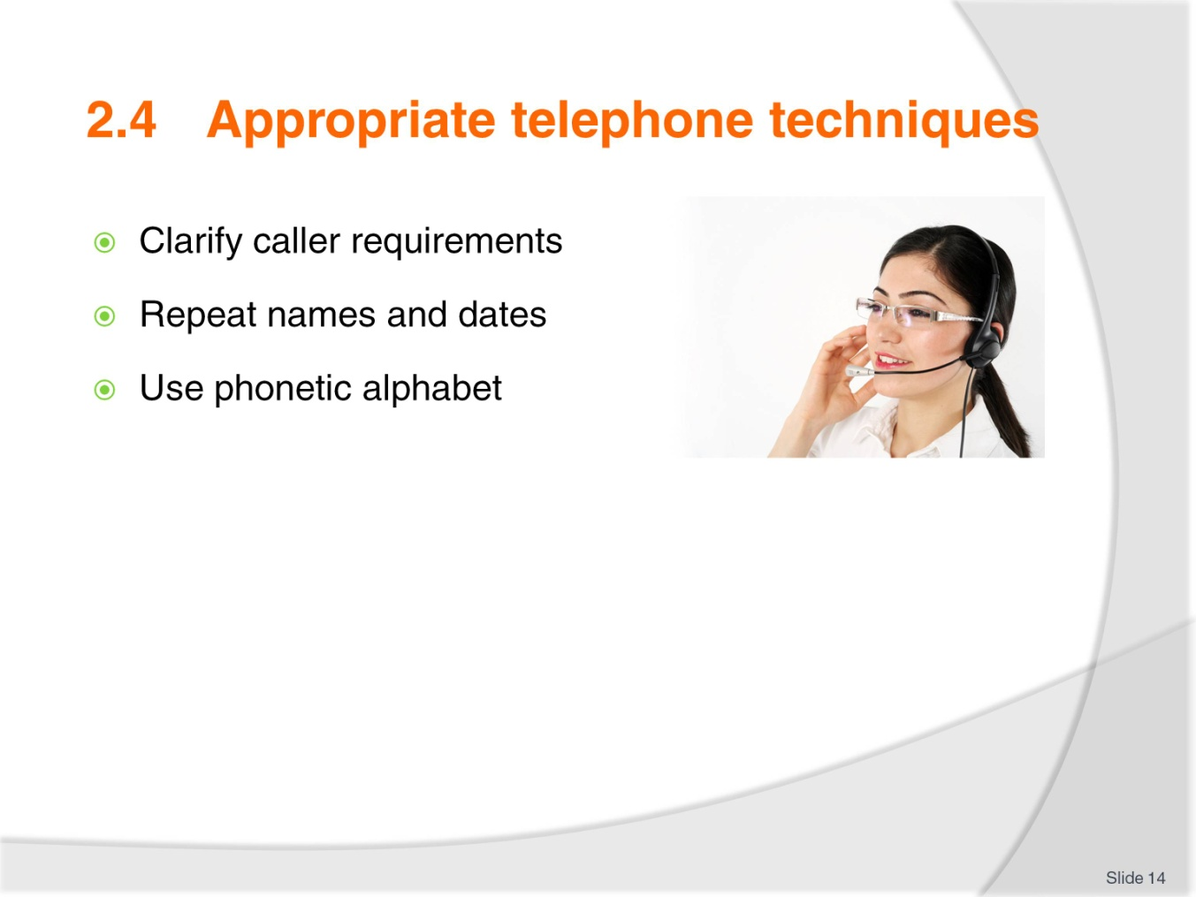
Slide No | Trainer Notes
Discuss how important it is to clarify the caller’s requirements – this requires that you LISTEN.
Repeat back names and dates and times – remind them of the 24 hour clock
Discuss the benefits of using the phonetic alphabet.

Slide
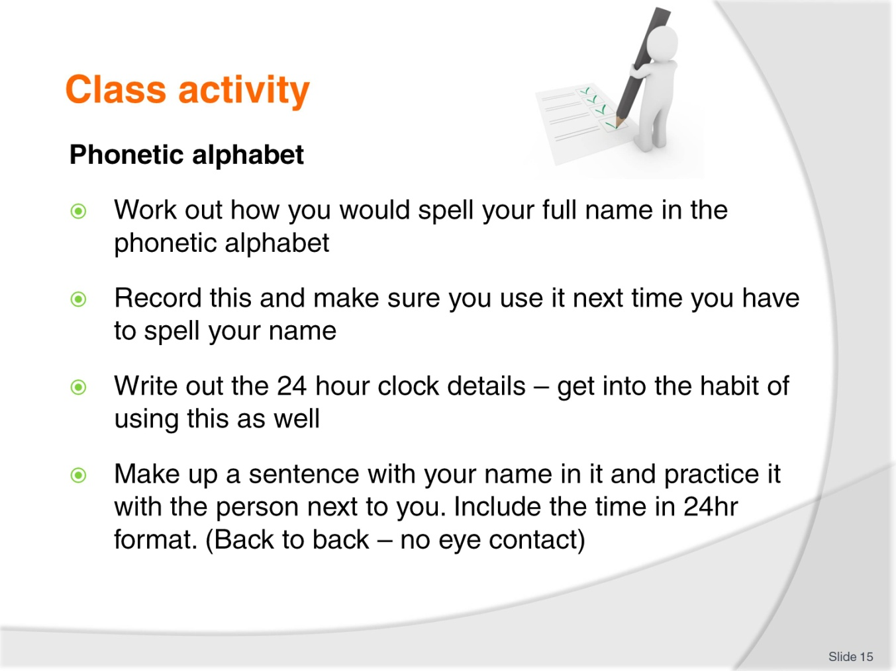
Slide No | Trainer Notes
 | This activity is to get the students to feel comfortable with the use of the phonetic alphabet and 24 hour clock.

Slide
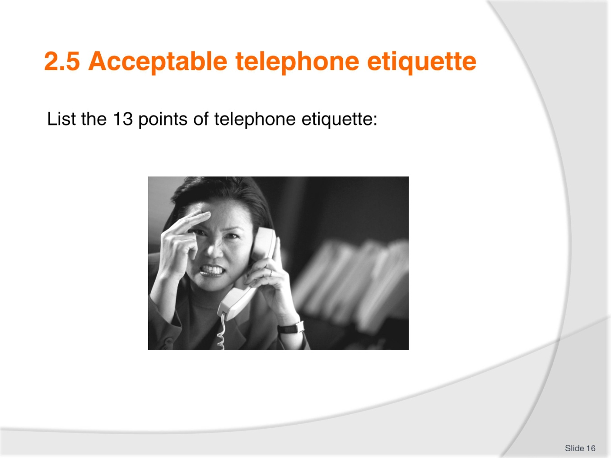
Slide No | Trainer Notes
What is telephone etiquette? Ask the students to talk about this before, discussing the 13 points:
- Answer the call within the second or third ring
- Always speak clearly and slowly
- Avoid extreme volumes
- Avoid jargon or hotel terminology
- Speak with a smile on your face
- Use an appropriate opening phrase
- Repeat the details back to the guest
- Always use the caller's name if known, otherwise, sir or madam
- Ask how something is spelt if you can’t understand
- Transfer calls promptly
- Never eat, drink or smoke while on the phone
- Use a suitable closing phrase - thank the caller for calling
- Always allow the caller to hang up first.

Slide
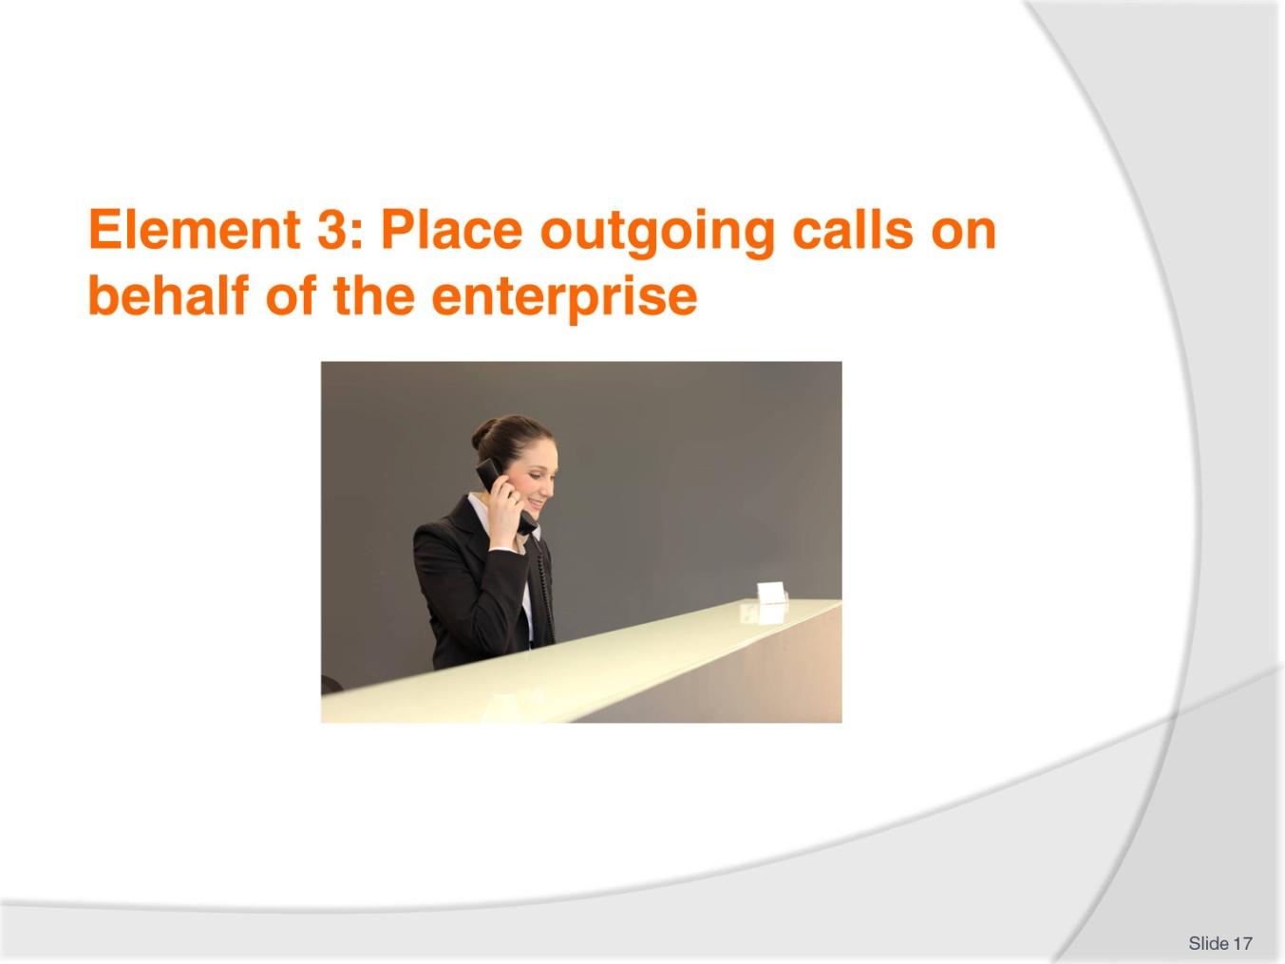
Slide No | Trainer Notes
 | Trainer advises students this element identifies the placement of outgoing calls on behalf of the enterprise.

Slide
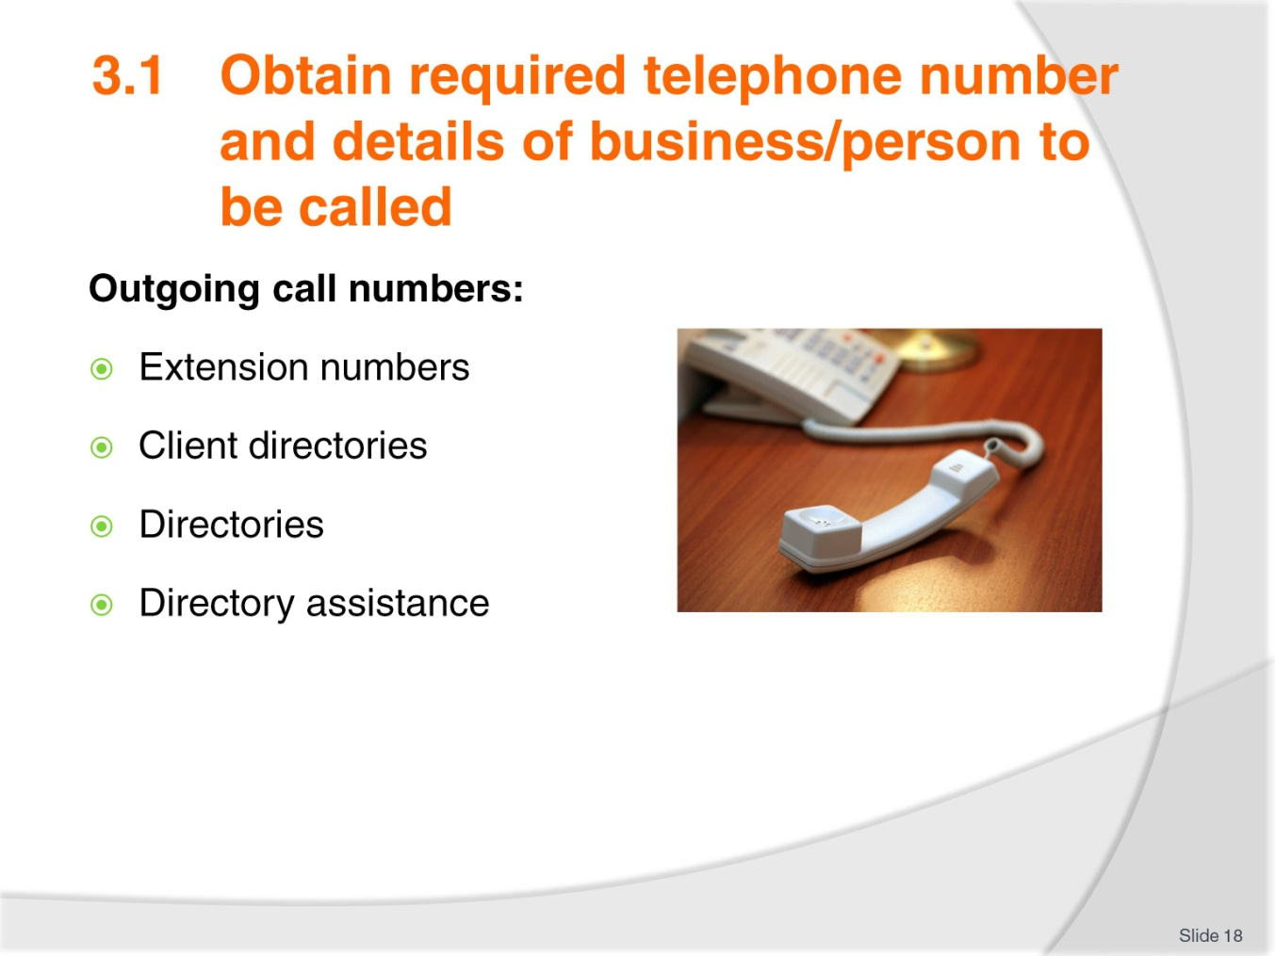
Slide No | Trainer Notes
Discuss how you would obtain the required number for a business or person to be called.
Could also include the use of the internet.

Slide
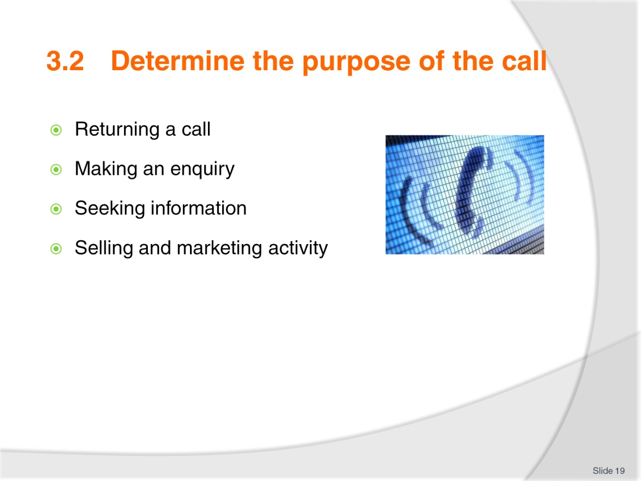
Slide No | Trainer Notes
Discuss with the student why you would need to determine the purpose of the call.
Discuss the individual points on the slide in relation to the purpose of the call.

Slide
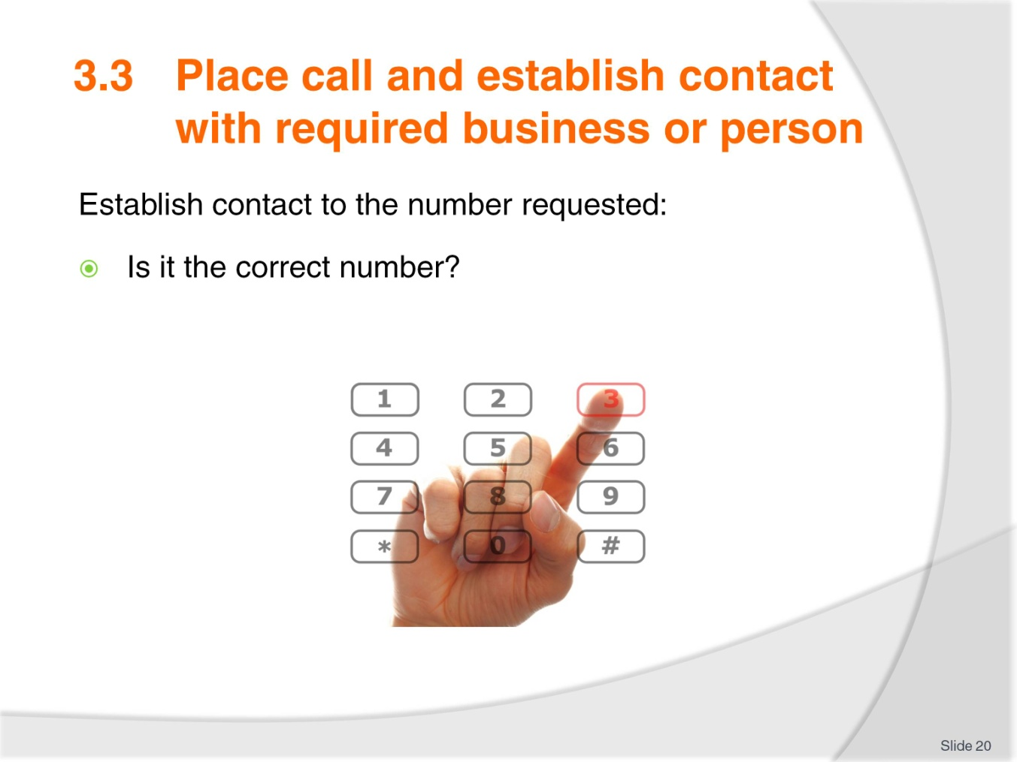
Slide No | Trainer Notes
Discuss the avenue of placing a call and make sure it is the person or business requested by the caller.
How will you know if it is the correct number?

Slide
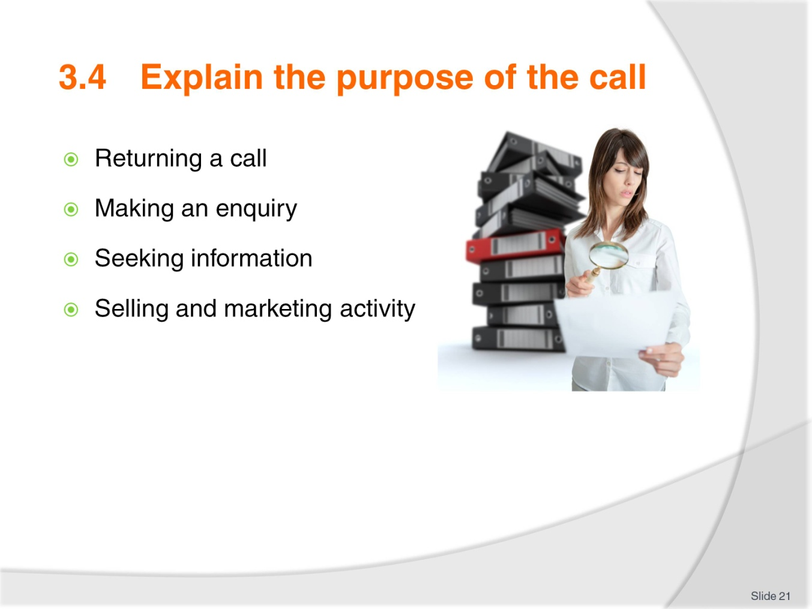
Slide No | Trainer Notes
 | Discuss the following points in relation to placing a call on behalf of an enterprise.

Slide
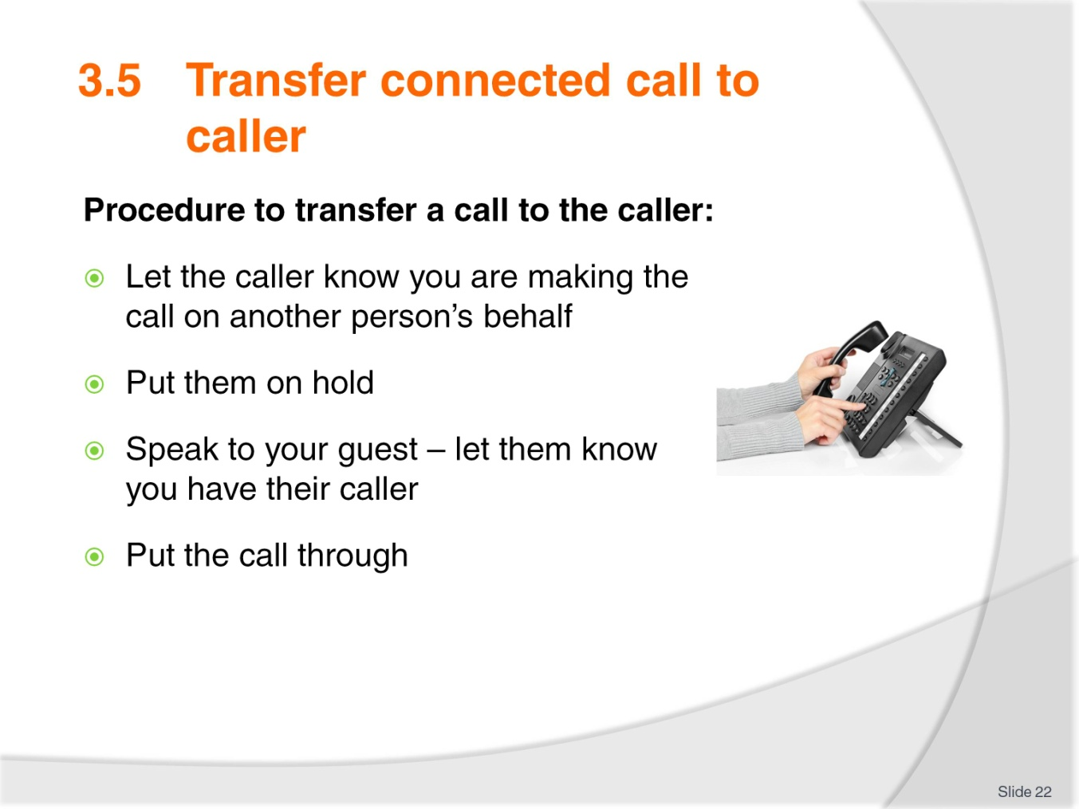
Slide No | Trainer Notes
Discuss this procedure
Keep everyone informed of what is happening
Discuss the essential element of knowing the equipment you are using. How do you put people on hold (don’t cut them off)? How do you open up the line to speak again?

Slide
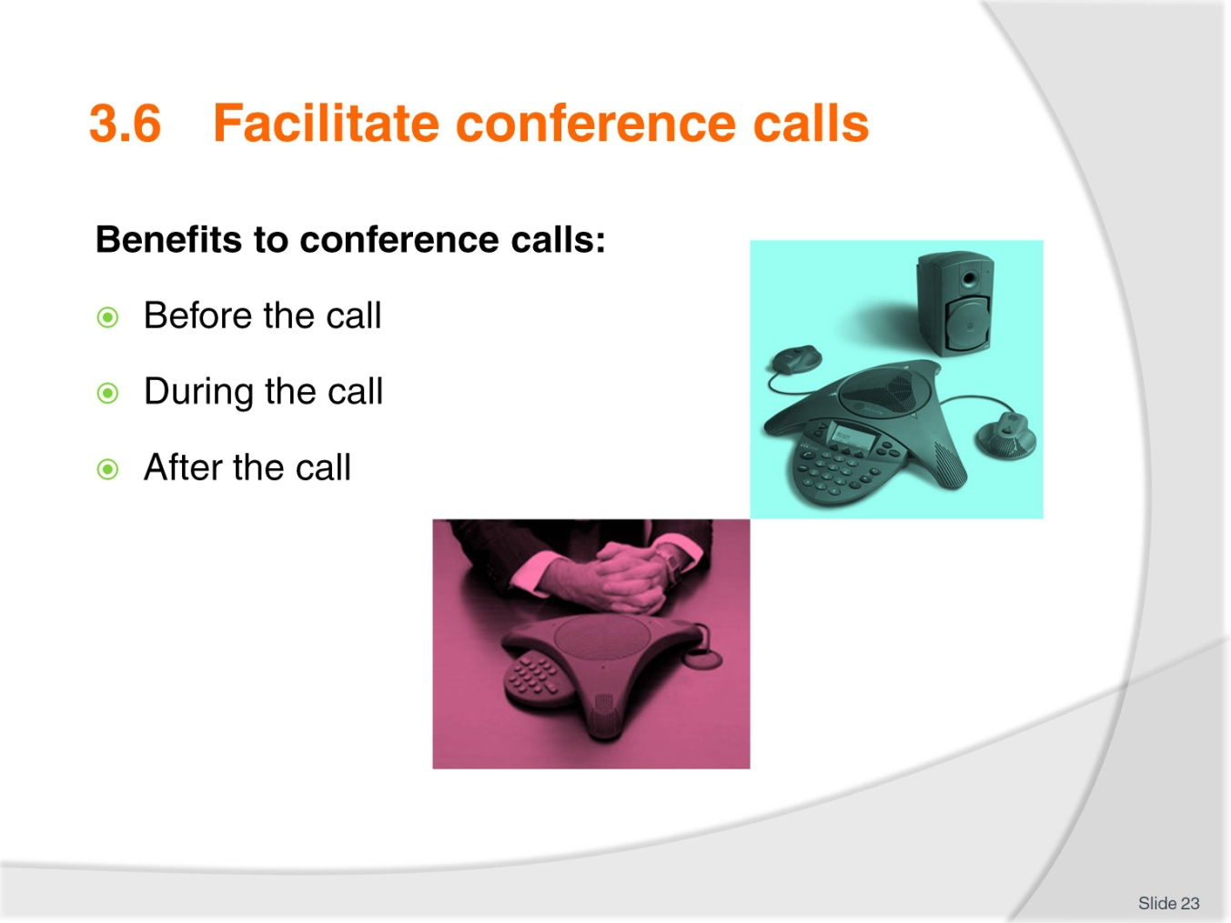
Slide No | Trainer Notes
Discuss why we use a conference call – what are the benefits?
Discuss these three aspects and how important they are to the process of the conference call.
Know the equipment and how to use if effectively.

Slide
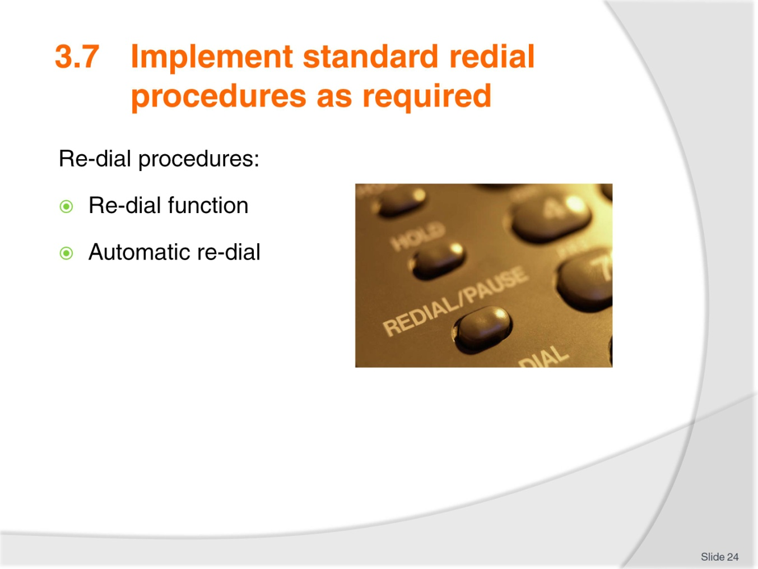
Slide No | Trainer Notes
Discuss the benefits of the redial function.
Discuss the benefits of automatic redial.

Slide
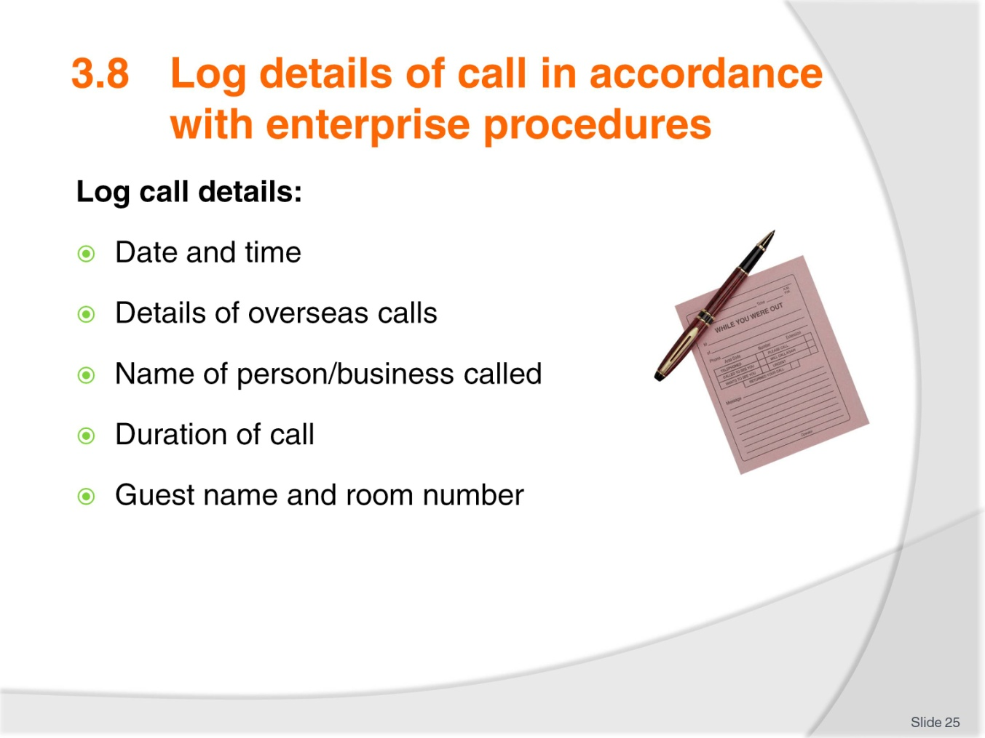
Slide No | Trainer Notes
Demonstrate that you don’t have to log calls if you have a PMS that will automatically log and charge the guest for the calls made
Manual process to log calls – what needs to be logged?

Slide
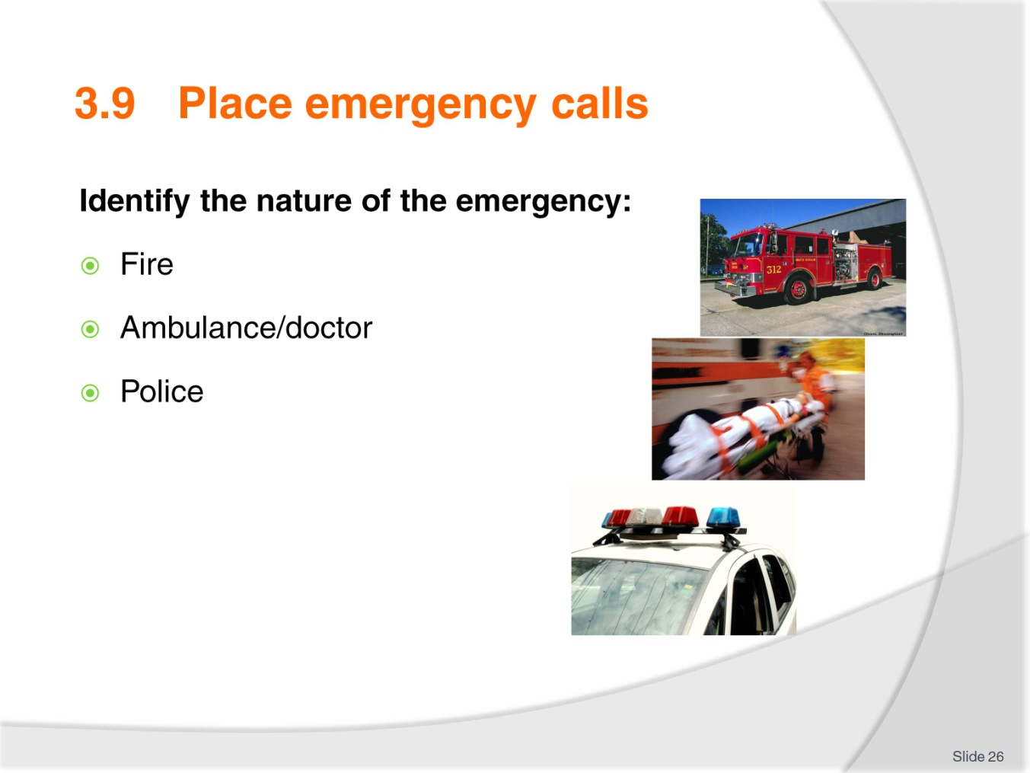
Slide No | Trainer Notes
Discuss with the class how you would identify which service to call
How would you be notified of an incident?

Slide
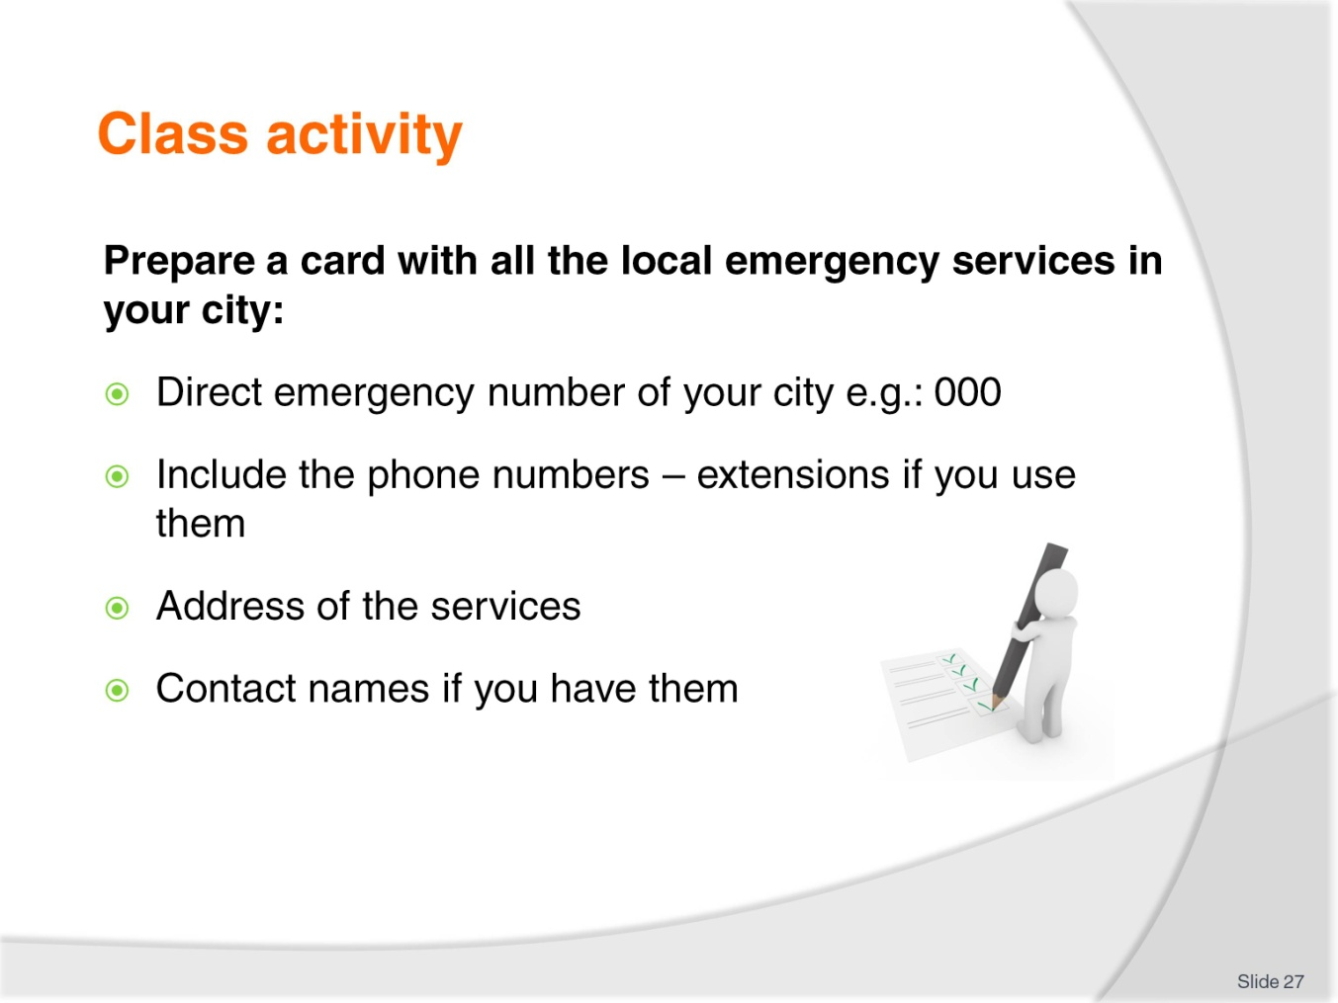
Slide No | Trainer Notes
Get the class to prepare an emergency card for all the services in their city
This adds to the student’s awareness of the emergency facilities. What is available, where it is and how you contact them.

Slide
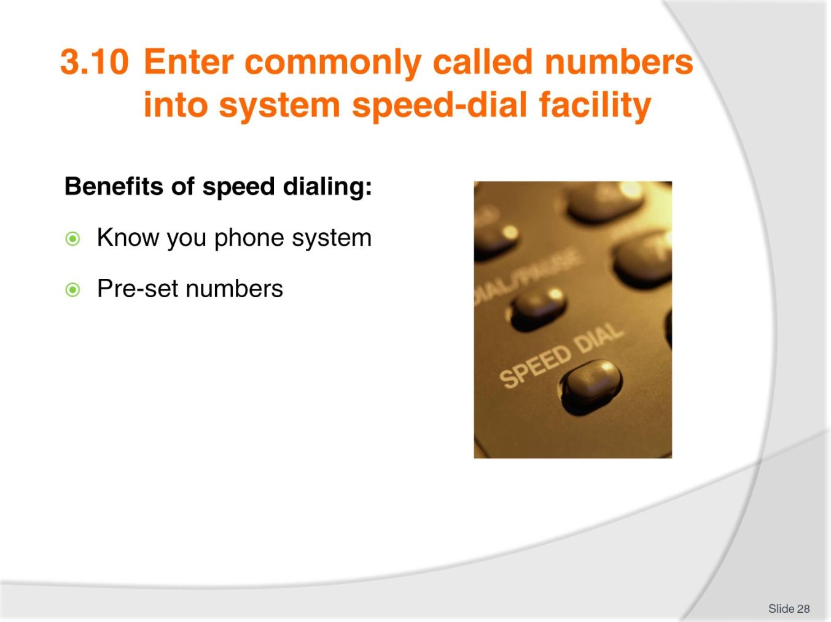
Slide No | Trainer Notes
Discuss the benefits of speed dialling:
How does this work?
What sort of numbers would you put into the presets?

Slide
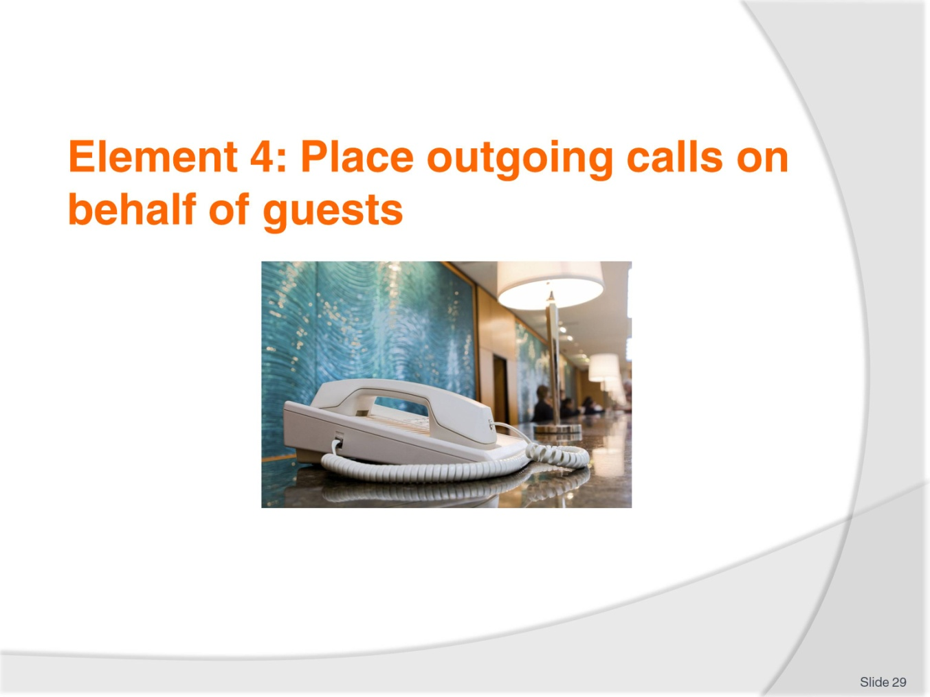
Slide No | Trainer Notes
 | Trainer advises students this element identifies the placement of outgoing calls on behalf of guests.

Slide
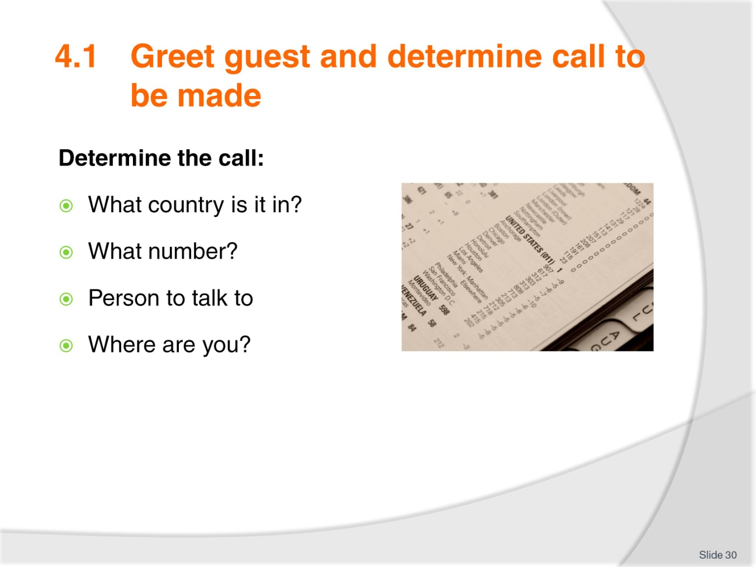
Slide No | Trainer Notes
 | Demonstrate what questions need to be asked to place a call for a guest.

Slide
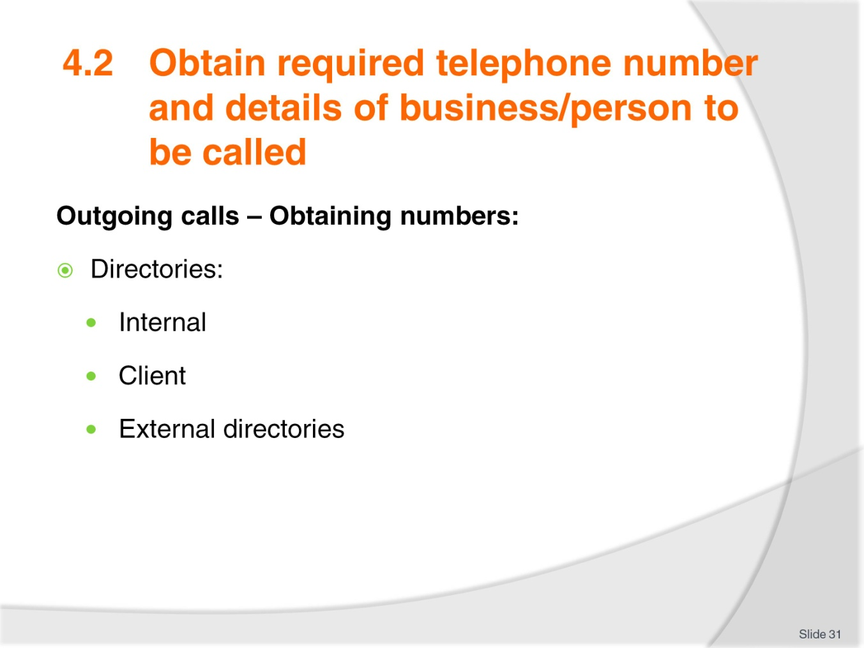
Slide No | Trainer Notes
 | Discuss the directories that can be used to find a number.

Slide
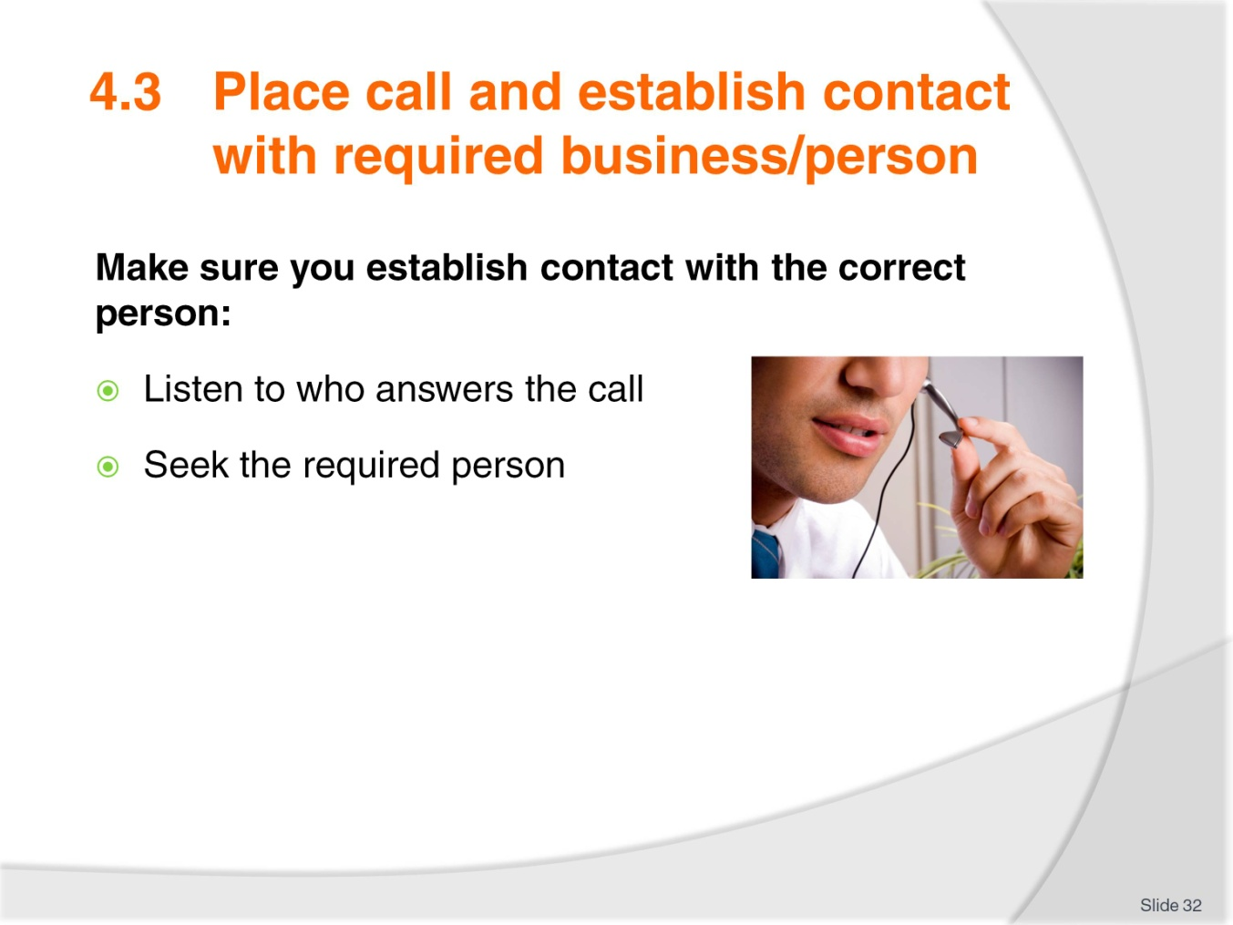
Slide No | Trainer Notes
Discuss placing a call and establishing contact with required person.
Use your listening skills – ask questions.

Slide
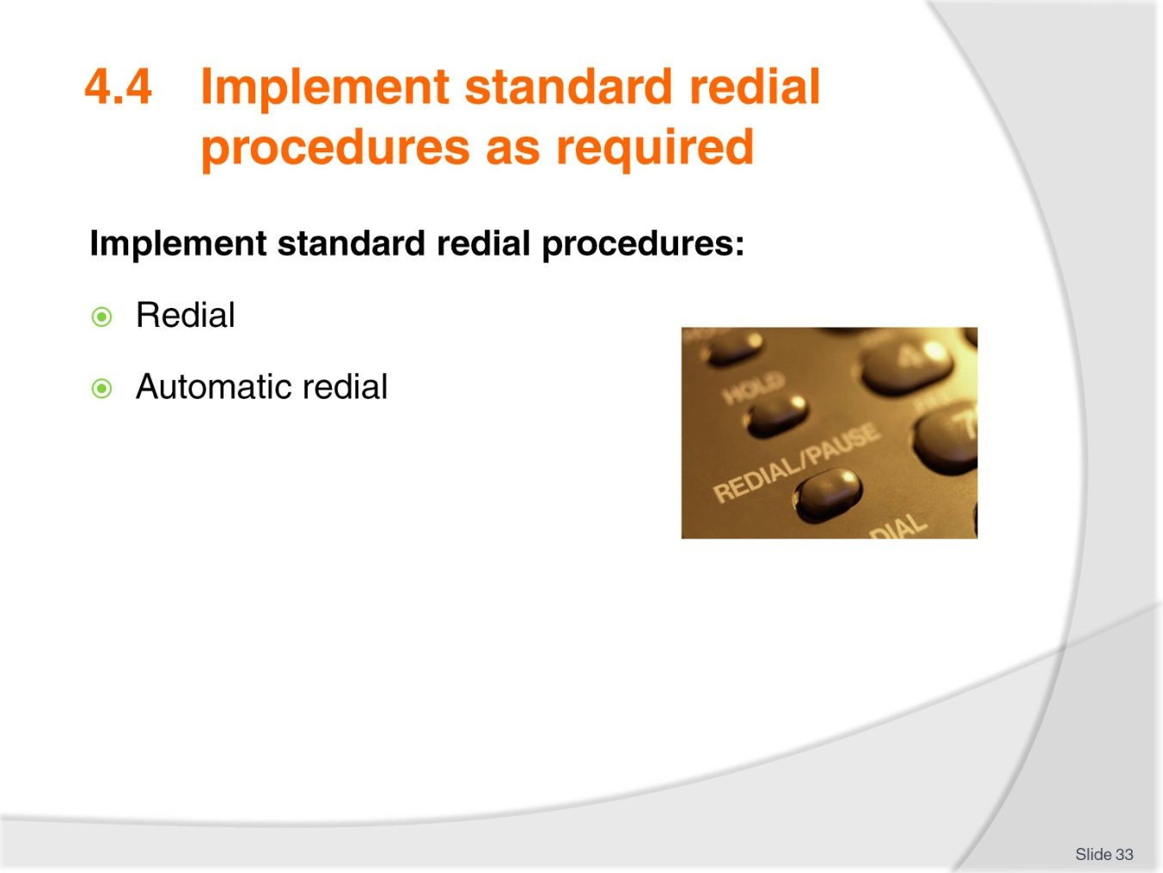
Slide No | Trainer Notes
 | Discuss the use of redial and automatic dialling.

Slide
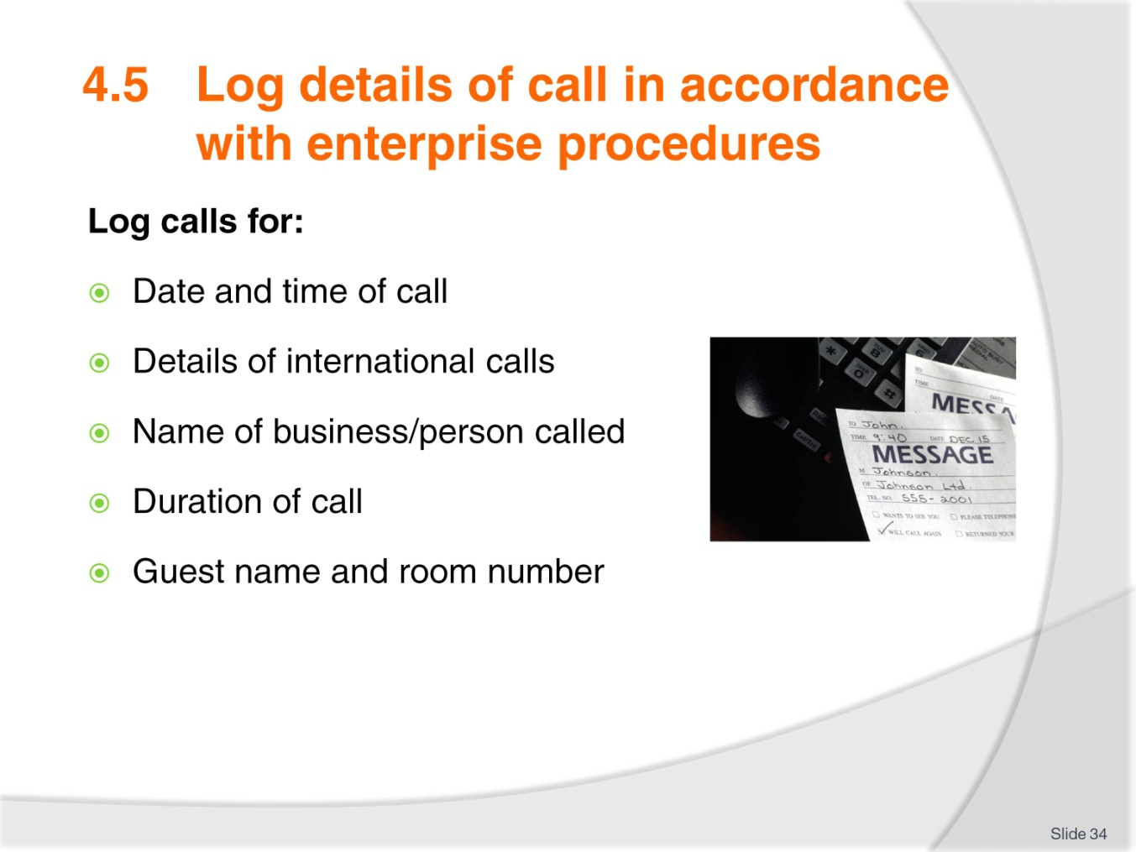
Slide No | Trainer Notes
 | Discuss the reason for logging calls and the importance of the information staying confidential.

Slide
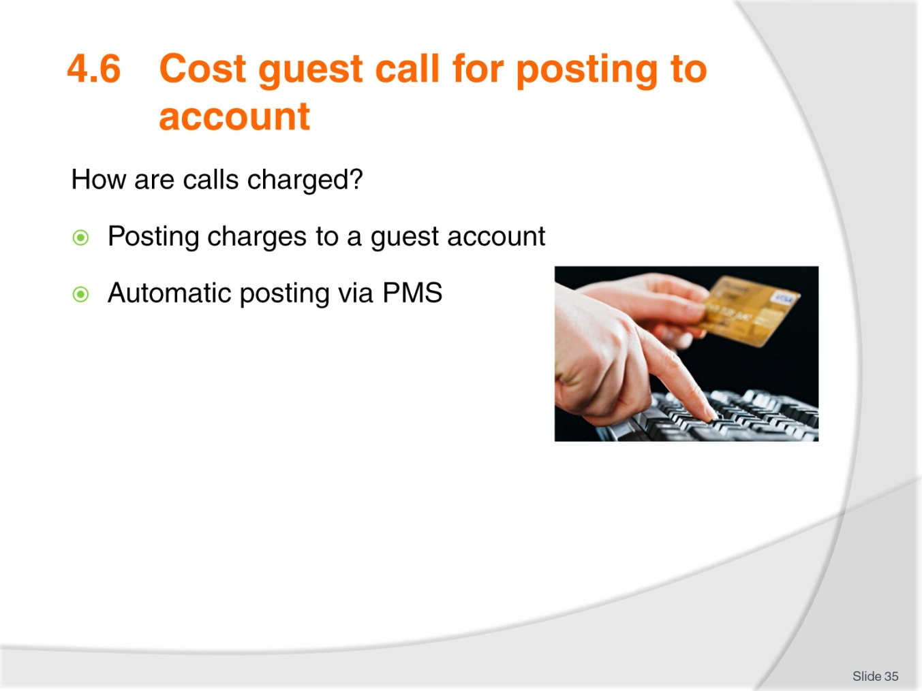
Slide No | Trainer Notes
Discuss how guests are charged for their calls – include surcharges.
How to cost guests to the guest folio – computerised and manual.

Slide

Slide No | Trainer Notes
 | Trainer concludes this unit and thanks trainees for their attention and participation.

Recommended training equipment
Computers (one per student) loaded with Front Office suggested software - Micros Fidelio currently using Opera Vs 5 (requires single dedicated server for Oracle)
Internet access
Printers with various papers and templates for messages
Fax machine
Hotel stationary
Switchboard/Telephone system one per each computer
Whiteboard
Simulated Hotel Front Desk with filing system and printer and computer access for 2 computers
Conference call equipment
Handsets & head sets
Pagers
Hotel plan with restaurants, leisure centre, porter area, function area etc with operating times and room types with Market segments, various rates etc.

Instructions for Trainers for using
PowerPoint – Presenter View
Connect your laptop or computer to your projector equipment as per manufacturers’ instructions.
In PowerPoint, on the Slide Show menu, click Set up Show.
Under Multiple monitors, select the Show Presenter View check box.
In the Display slide show on list, click the monitor you want the slide show presentation to appear on.
Source: http://office.microsoft.com
Note:
In Presenter View:
You see your notes and have full control of the presentation
Your trainees only see the slide projected on to the screen
More Information
You can obtain more information on how to use PowerPoint from the Microsoft Online Help Centre, available at: http://office.microsoft.com/training/training.aspx?AssetID=RC011298761033
Note Regarding Currency of URLs
Please note that where references have been made to URLs in these training resources trainers will need to verify that the resource or document referred to is still current on the internet. Trainers should endeavour, where possible, to source similar alternative examples of material where it is found that either the website or the document in question is no longer available online.

Appendix – ASEAN acronyms
AADCP | ASEAN – Australia Development Cooperation Program
ACCSTP | ASEAN Common Competency Standards for Tourism Professionals
AEC | ASEAN Economic Community
AMS | ASEAN Member States
ASEAN | Association of Southeast Asian Nations
ASEC | ASEAN Secretariat
ATM | ASEAN Tourism Ministers
ATPMC | ASEAN Tourism Professionals Monitoring Committee
ATPRS | ASEAN Tourism Professional Registration System
ATFTMD | ASEAN Task Force on Tourism Manpower Development
CATC | Common ASEAN Tourism Curriculum
MRA | Mutual Recognition Arrangement
MTCO | Mekong Tourism Coordinating Office
NTO | National Tourism Organisation
NTPB | National Tourism Professional Board
RQFSRS | Regional Qualifications Framework and Skills Recognition System
TPCB | Tourism Professional Certification Board







